PRACTICAL NO: 01 (A)
Title: Design a simple neural network model
Source Code:
# Aim: Design a simple neural network model
# w, b, x takes the value of weight, bias and input respectively
w = float(input("Enter the value for weight: "))
b = float(input("Enter the value for bias: "))
x = float(input("Enter the value for input: "))
# The net input is calculated with the formula yin = b + wx
print("The net input (yin): ")
yin = float(b + (w * x))
print(yin)

Output:
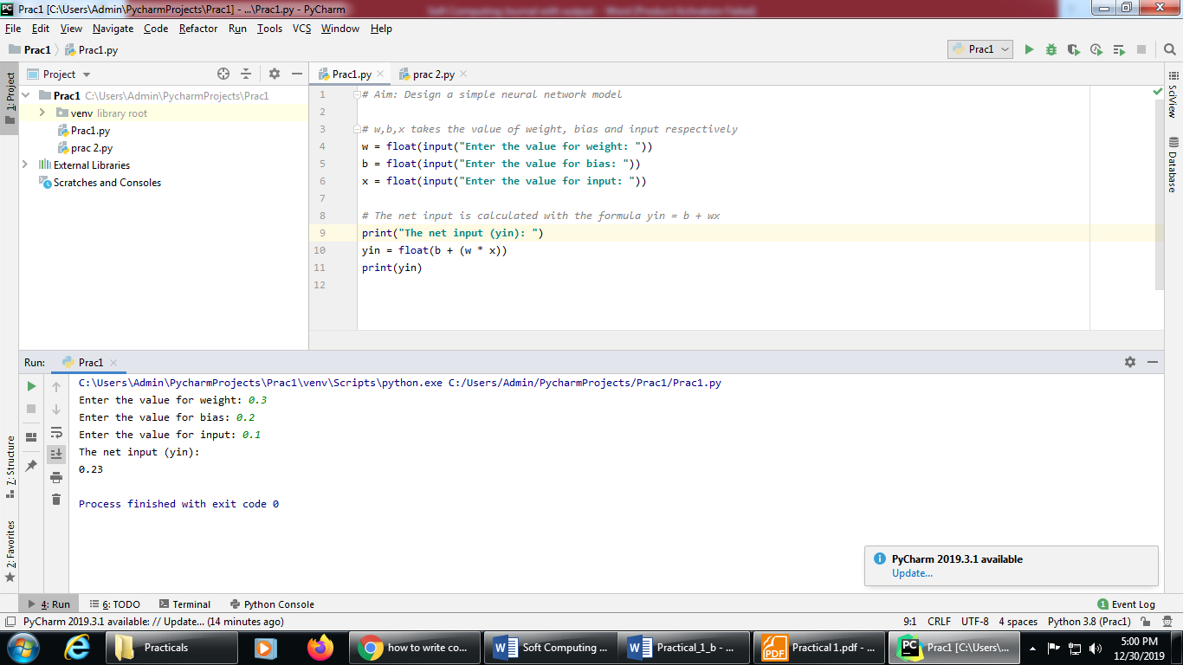

PRACTICAL NO: 01 (B)
Title: Calculate the output of neural net.
Source Code for Problem statement A:
# Aim: Calculate the output of neural net where input X = [x1, x2, x3] = [0.3, 0.5, 0.6] &
# Weight W = [w1, w2, w3] = [0.2, 0.1, -0.3]
# n will take no of neurons in the network.
n = int(input("Enter the number of input neurons: "))
# w will take weight & x will take the input
w = [ ]
x = [ ]
# taking the value of input and their weight
for i in range(0,n):
a = float(input("Enter the input: "))
x.append(a)
b = float(input("Enter the weight: "))
w.append(b)
print("The given weights are: ")
print(w)
print("The given input are: " )
print(x)
y = 0.0
for i in range(0,n):
y = y + (w[i]*x[i])
print("The net input is ")
print (round(y,3))

Output:
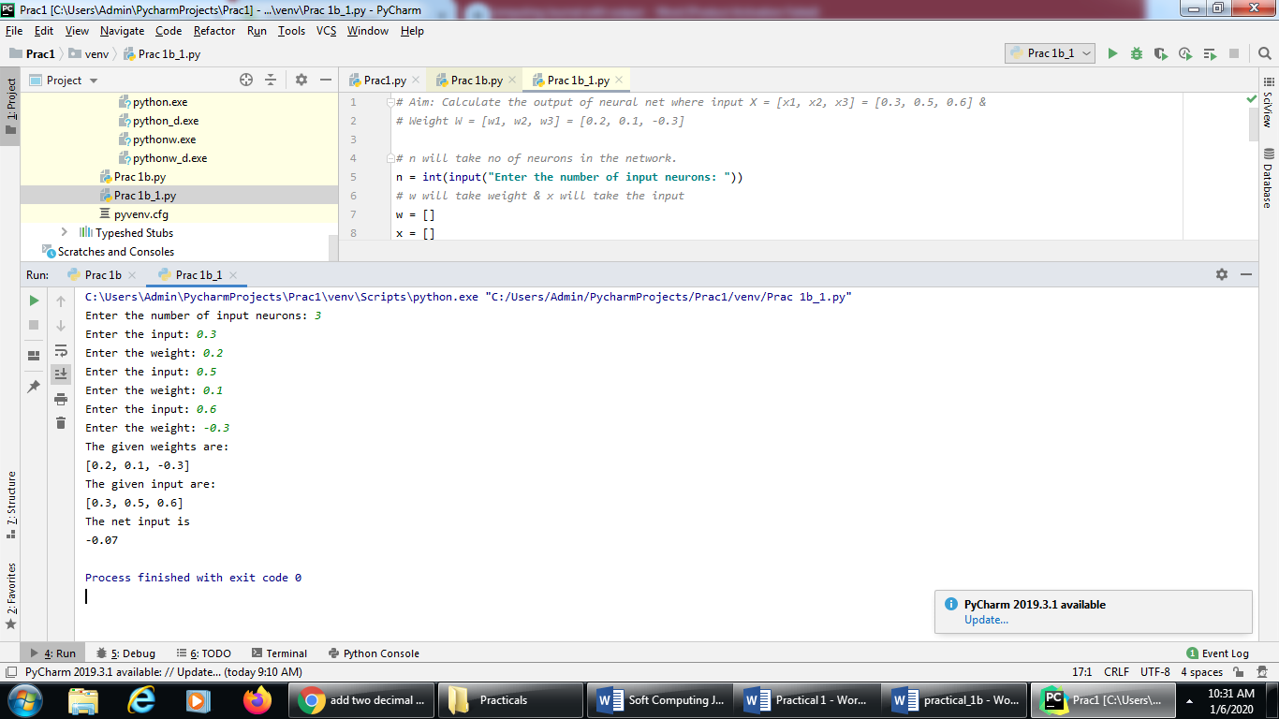
Source Code for Problem statement B:
# Aim: Calculate the output of neural net where input X = [x1, x2] = [0.2, 0.6] &
# Weight W = [w1, w2] = [0.3,0.7] & bias = 0.45
# bias = 0.45
bias = float(input("Enter the value of bias: "))
# n will take no of neurons in the network.
n = int(input("Enter the number of input neurons: "))
# w will take weight & x will take the input
w = []
x = []
for i in range(0,n):
a = float(input("Enter the input: "))
x.append(a)
b = float(input("Enter the weight: "))
w.append(b)
print("The given weights are: ")
print(w)
print("The given input are: " )
print(x)
y = bias
for i in range(0,n):
y = y + (w[i]*x[i])
print("The net input is ")
print (round(y,3))

Output:
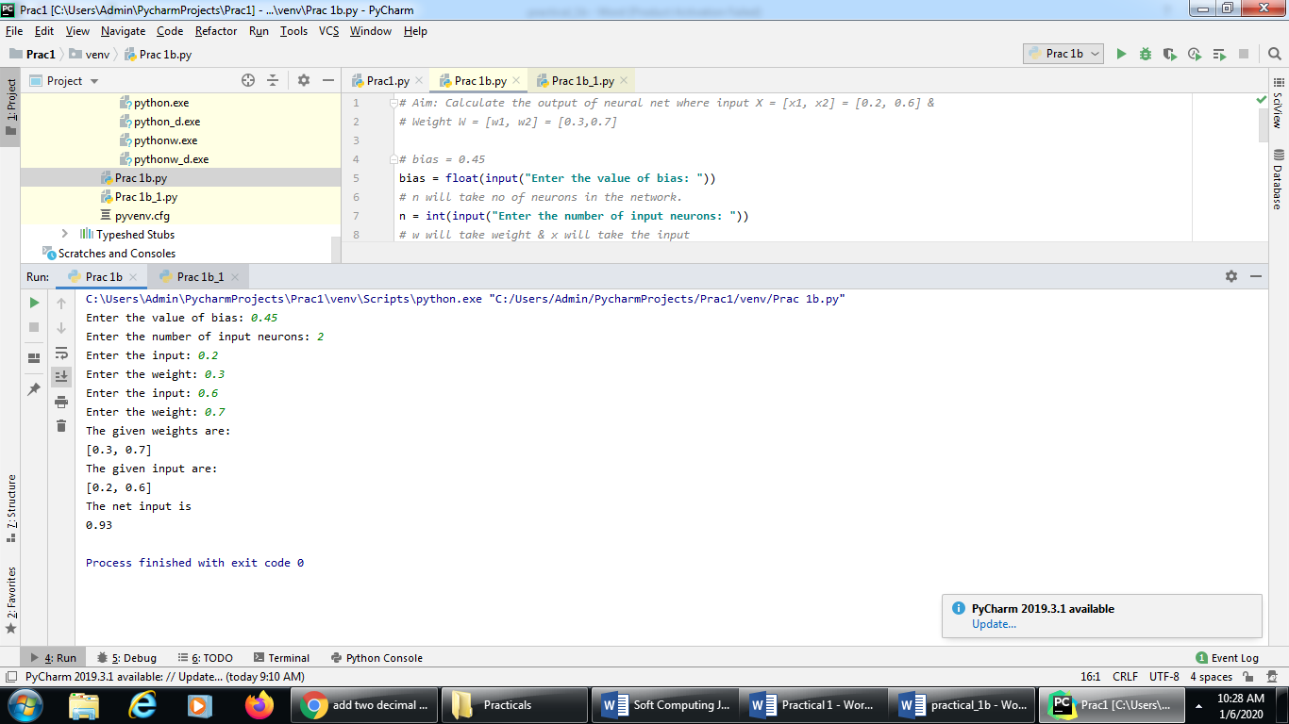
Source Code for Problem statement C:
# Aim: Calculate the output of neural net where input X = [x1, x2, x3] = [0.8, 0.6, 0.4]] &
# Weight W = [w1, w2, w3] = [0.1, 0.3, -0.2] & bias =0.35.
# Apply Binary & Bipolar Sigmoidal activation function
# import math so that we can use mathematical function exp()
import math
bias = float(input("Enter the value of bias: "))
# n will take no of neurons in the network.
n = int(input("Enter the number of input neurons: "))
# w will take weight & x will take the input
w = [ ]
x = [ ]
# taking the value of input and their weight
for i in range(0,n):
a = float(input("Enter the input: "))
x.append(a)
b = float(input("Enter the weight: "))
w.append(b)
print("The given weights are: ")
print(w)
print("The given input are: " )
print(x)
y = bias
for i in range(0,n):
y = y + (w[i]*x[i])
print("The calculated net input y : ")
print(y)
# Applying Binary Sigmoidal function on the net input i.e y
binary = 1/(1+ (math.exp(-y)))
print("The output after applying binary sigmoidal function activation ")
print (round(binary, 3))
# Applying Bipolar Sigmoidal function on the net input i.e y
bipolar = -1+(2/(1+ (math.exp(-y))))
print("The output after applying bipolar sigmoidal function activation ")
print (round(bipolar, 3))

Output:
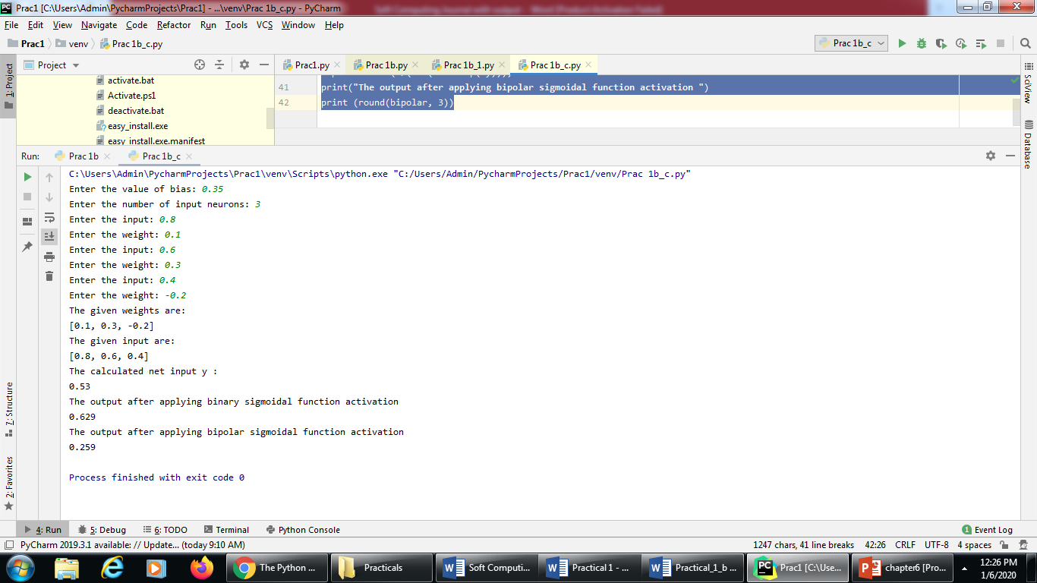

PRACTICAL NO: 02 (A)
Title: Implement AND/NOT function using McCulloch-Pits neuron
Source Code:
#Aim: Generate AND/NOT function using McCulloch-Pitts (M-P) neural net.
# Logic: In the case of ANDNOT function,
# the response is true if the first input is true and the second input is false.
# Threshold for this neural network will be theta > = 1
# There are two inputs and binary values will be taken as input i.e. either 0 or 1.
num_ip = int(input("Enter the number of inputs : "))
print("For the ", num_ip , " inputs calculate the net input using yin = x1w1 + x2w2 ")
theta = 1
x1 =[]
x2 =[]
for i in range(0,num_ip):
a = int(input("Enter the input x1: "))
x1.append(a)
b = int(input("Enter the input x2: "))
x2.append(b)
print("x1 = ", x1)
print("x2 = ", x2)
print("Value of theta is 1.")
print("Case 1: For calculating the net input the weight is considered as w1 = w2 = 1")
w1 = w2 = 1
case_y1 =[]
case_yin1 = []
print("x1 w1 x2 w2 case_y1 case_yin1")
for i in range(0,num_ip):
case_y1.append(x1[i]*w1 + x2[i]*w2)
if (case_y1[i] >= theta):
case_yin1.append( 1 )
else:
case_yin1.append( 0 )
print(x1[i]," ", w1," ",x2[i]," ",w2," ", case_y1[i]," ",case_yin1[i])
print("From the calculated net inputs, it is not possible to fire the neuron form input (1, 0) only."
"\n Hence, these weights are not suitable. ")
print("Case 2: For calculating the net input the weight is considered as w1 = 1, w2 = -1")
w1 = 1
w2 = -1
case_y2 =[]
case_yin2 = []
print("x1 w1 x2 w2 case_y2 case_yin2")
for i in range(0,num_ip):
case_y2.append(x1[i]*w1 + x2[i]*w2)
if (case_y2[i] >= theta):
case_yin2.append( 1 )
else:
case_yin2.append( 0 )
print(x1[i]," ", w1," ",x2[i]," ",w2," ", case_y2[i]," ",case_yin2[i])
print("From the calculated net inputs, it is possible to fire the neuron form input (1, 0) only."
"\n Hence, these weights are suitable. ")

Output:
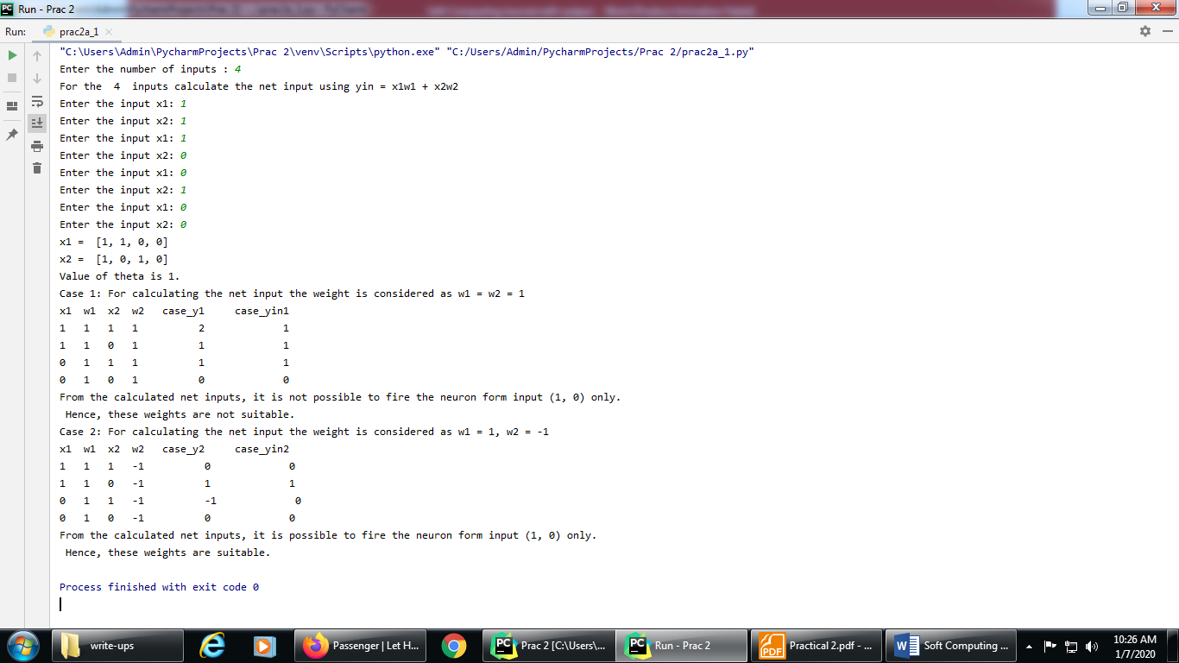

PRACTICAL NO: 02 (B)
Title: Generate XOR function using McCulloch-Pitts neural net.
XOR neural network:
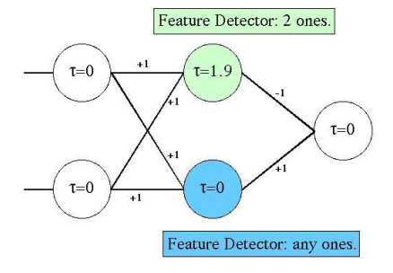
Source code:
#Aim: Creating XOR network with the two neurons in the hidden layers.
#Getting weights and threshold value
import numpy as np
print('Enter weights')
w11=int(input('Weight w11='))
w12=int(input('weight w12='))
w21=int(input('Weight w21='))
w22=int(input('weight w22='))
v1=int(input('weight v1='))
v2=int(input('weight v2='))
print('Enter Threshold Value')
theta=int(input('theta='))
x1=np.array([0, 0, 1, 1])
x2=np.array([0, 1, 0, 1])
z=np.array([0, 1, 1, 0])
con=1
y1=np.zeros((4,))
y2=np.zeros((4,))
y=np.zeros((4,))
while con==1:
zin1=np.zeros((4,))
zin2=np.zeros((4,))
zin1=x1*w11+x2*w21
zin2=x1*w21+x2*w22
print("z1",zin1)
print("z2",zin2)
for i in range(0,4):
if zin1[i]>=theta:
y1[i]=1
else:
y1[i]=0
if zin2[i]>=theta:
y2[i]=1
else:
y2[i]=0
yin=np.array([])
yin=y1*v1+y2*v2
for i in range(0,4):
if yin[i]>=theta:
y[i]=1
else:
y[i]=0
print("yin",yin)
print('Output of Net')
y=y.astype(int)
print("y",y)
print("z",z)
if np.array_equal(y,z):
con=0
else:
print("Net is not learning enter another set of weights and Threshold value")
w11=input("Weight w11=")
w12=input("weight w12=")
w21=input("Weight w21=")
w22=input("weight w22=")
v1=input("weight v1=")
v2=input("weight v2=")
theta=input("theta=")
print("McCulloch-Pitts Net for XOR function")
print("Weights of Neuron Z1")
print(w11)
print(w21)
print("weights of Neuron Z2")
print(w12)
print(w22)
print("weights of Neuron Y")
print(v1)
print(v2)
print("Threshold value")
print(theta)

Output:
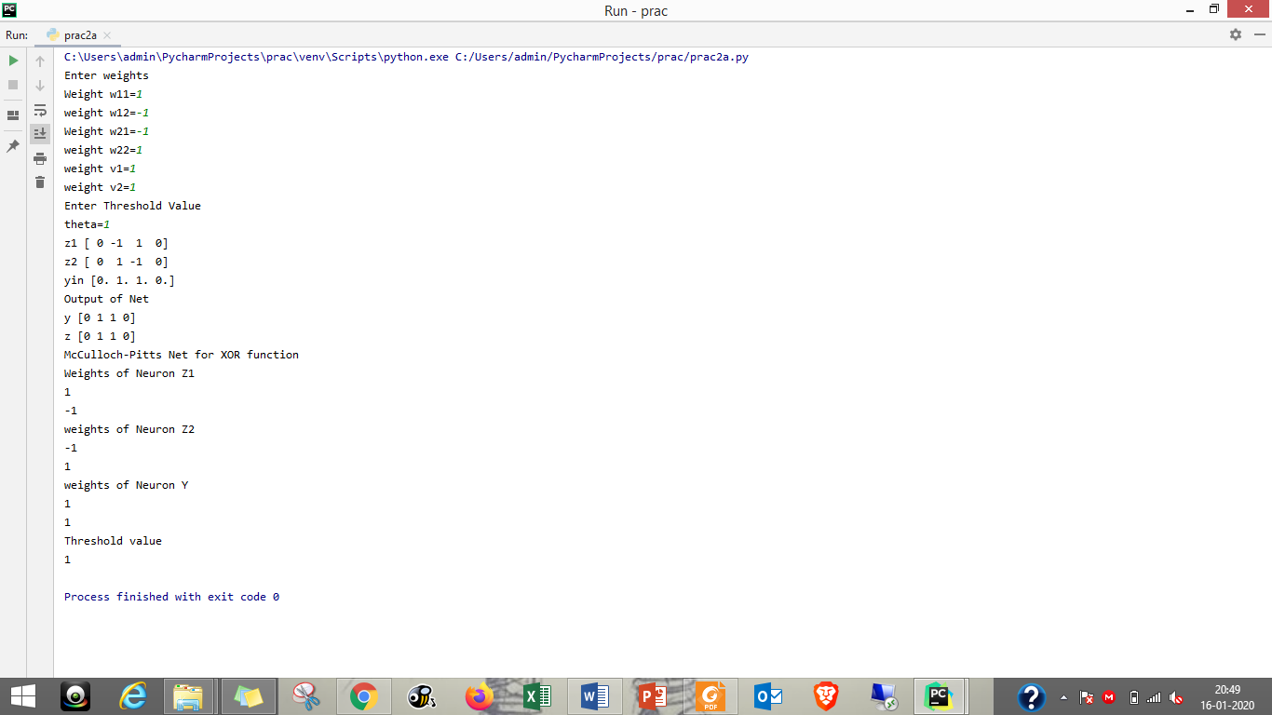

PRACTICAL NO: 03 (A)
Title: Write a program to implement Hebb’s rule.
Data for input pattern:
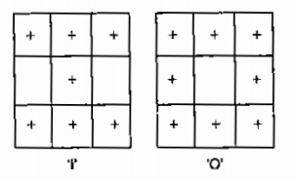
Source Code:
#Aim: Using Hebb rule, find the weights required to perform the above
# classifications of the given input patterns. The patterns show 3x3 matrix
# form in the square. The '+' symbol represents the value "+1" and the empty
# square represents "-1". Consider "I" belongs to the member of the class (so
# has target value 1) and "O" does not belong to the members of the class
#(so has target value -1)
import numpy as np
#first pattern
x1=np.array([1,1,1,-1,1,-1,1,1,1])
#second pattern
x2=np.array([1,1,1,1,-1,1,1,1,1])
#initialize bais value
b=0
#define target
y=np.array([1,-1])
wtold=np.zeros((9,))
wtnew=np.zeros((9,))
wtnew=wtnew.astype(int)
wtold=wtold.astype(int)
bais=0
print("First input with target =1")
for i in range(0,9):
wtold[i]=wtold[i]+x1[i]*y[0]
wtnew=wtold
b=b+y[0]
print("Second input with target =-1")
for i in range(0,9):
wtnew[i]=wtold[i]+x2[i]*y[1]
b=b+y[1]
print("new wt =", wtnew)
print("Bias value",b)

Output:
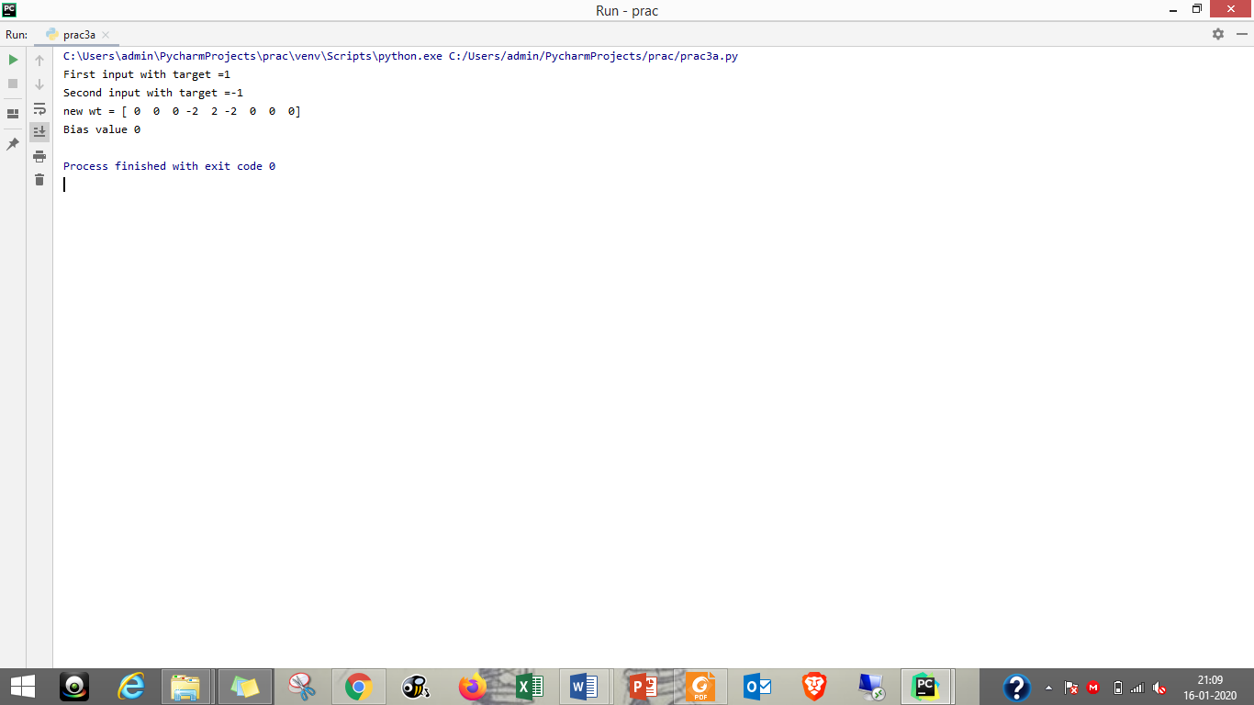

PRACTICAL NO: 03 (B)
Title: Write a program to implement Delta rule.
Source Code:
#supervised learning
import numpy as np
import time
np.set_printoptions(precision=2)
x=np.zeros((3,))
weights=np.zeros((3,))
desired=np.zeros((3,))
actual=np.zeros((3,))
for i in range(0,3):
x[i]=float(input("Initial inputs:"))
for i in range(0,3):
weights[i]=float(input("Initial weights:"))
for i in range(0,3):
desired[i]=float(input("Desired output:"))
a=float(input("Enter learning rate:"))
actual=x*weights
print("actual",actual)
print("desired",desired)
while True:
if np.array_equal(desired,actual):
break #no change
else:
for i in range(0,3):
weights[i]=weights[i]+a*(desired[i]-actual[i])
actual=x*weights
print("weights",weights)
print("actual",actual)
print("desired",desired)
print("*"*30)
print("Final output")
print("Corrected weights",weights)
print("actual",actual)
print("desired",desired)

Output:
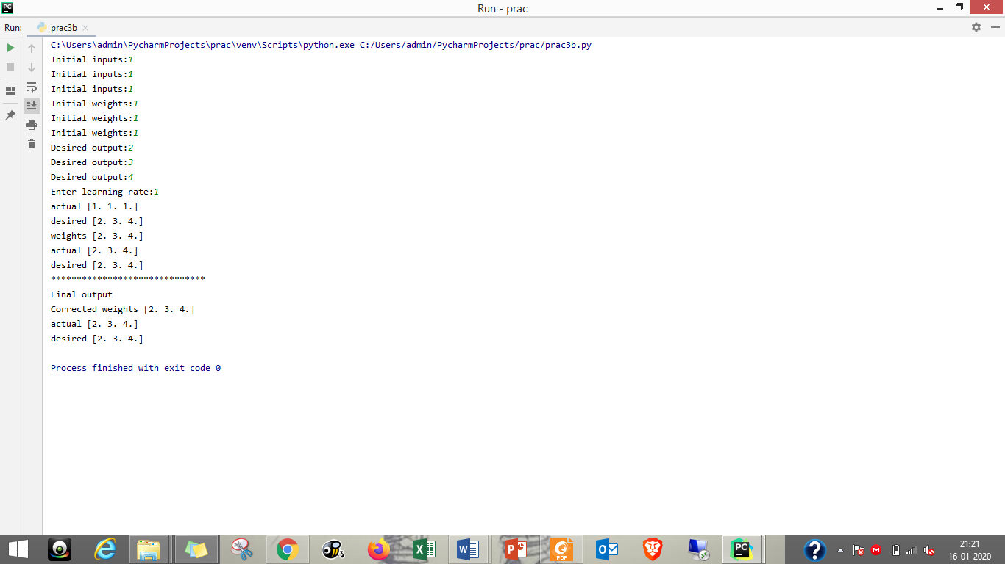

PRACTICAL NO: 04 (A)
Title: Write a program for Back Propagation Algorithm.
Neural Network for Back Propagation:
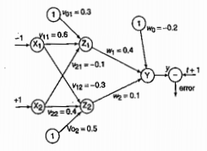
Source Code:
#Aim: Implement the back propogation algorithm for the above
# neural network
import numpy as np
import decimal
import math
np.set_printoptions(precision=2)
v1=np.array([0.6, 0.3])
v2=np.array([-0.1, 0.4])
w=np.array([-0.2,0.4,0.1])
b1=0.3
b2=0.5
x1=0
x2=1
alpha=0.25
print("calculate net input to z1 layer")
zin1=round(b1+ x1*v1[0]+x2*v2[0],4)
print("z1=",round(zin1,3))
print("calculate net input to z2 layer")
zin2=round(b2+ x1*v1[1]+x2*v2[1],4)
print("z2=",round(zin2,4))
print("Apply activation function to calculate output")
z1=1/(1+math.exp(-zin1))
z1=round(z1,4)
z2=1/(1+math.exp(-zin2))
z2=round(z2,4)
print("z1=",z1)
print("z2=",z2)
print("calculate net input to output layer")
yin=w[0]+z1*w[1]+z2*w[2]
print("yin=",yin)
print("calculate net output")
y=1/(1+math.exp(-yin))
print("y=",y)
fyin=y *(1- y)
dk=(1-y)*fyin
print("dk",dk)
dw1= alpha * dk * z1
dw2= alpha * dk * z2
dw0= alpha * dk
print("compute error portion in delta")
din1=dk* w[1]
din2=dk* w[2]
print("din1=",din1)
print("din2=",din2)
print("error in delta")
fzin1= z1 *(1-z1)
print("fzin1",fzin1)
d1=din1* fzin1
fzin2= z2 *(1-z2)
print("fzin2",fzin2)
d2=din2* fzin2
print("d1=",d1)
print("d2=",d2)
print("Changes in weights between input and hidden layer")
dv11=alpha * d1 * x1
print("dv11=",dv11)
dv21=alpha * d1 * x2
print("dv21=",dv21)
dv01=alpha * d1
print("dv01=",dv01)
dv12=alpha * d2 * x1
print("dv12=",dv12)
dv22=alpha * d2 * x2
print("dv22=",dv22)
dv02=alpha * d2
print("dv02=",dv02)
print("Final weights of network")
v1[0]=v1[0]+dv11
v1[1]=v1[1]+dv12
print("v=",v1)
v2[0]=v2[0]+dv21
v2[1]=v2[1]+dv22
print("v2",v2)
w[1]=w[1]+dw1
w[2]=w[2]+dw2
b1=b1+dv01
b2=b2+dv02
w[0]=w[0]+dw0
print("w=",w)
print("bias b1=",b1, " b2=",b2)

Output:
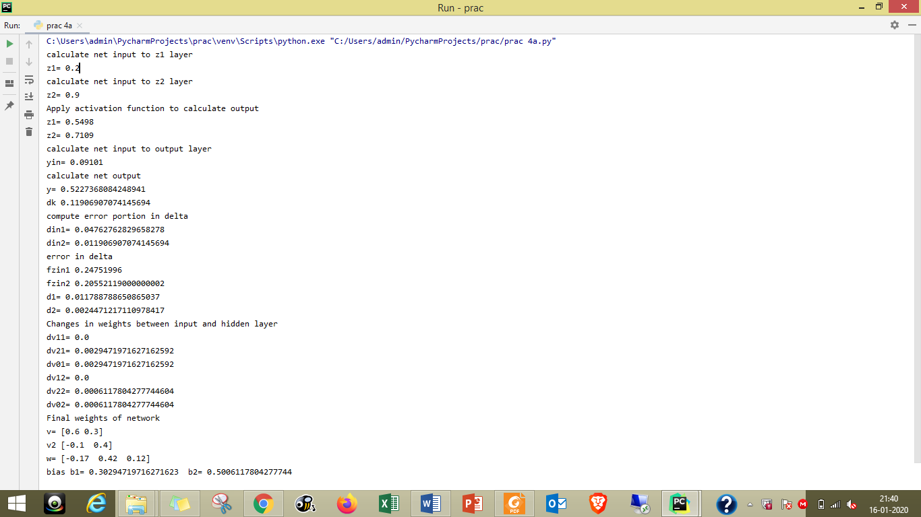
PRACTICAL NO: 04 (B)
Title: Write a Program For Error Back Propagation Algorithm (Ebpa) Learning
Source Code:
import math
a0=-1
t=-1
w10=float(input("Enter weight first network"))
b10=float(input("Enter base first network:"))
w20=float(input("Enter weight second network:"))
b20=float(input("Enter base second network:"))
c=float(input("Enter learning coefficient:"))
n1=float(w10*c+b10)
a1=math.tanh(n1)
n2=float(w20*a1+b20)
a2=math.tanh(float(n2))
e=t-a2
s2=-2*(1-a2*a2)*e
s1=(1-a1*a1)*w20*s2
w21=w20-(c*s2*a1)
w11=w10-(c*s1*a0)
b21=b20-(c*s2)
b11=b10-(c*s1)
print("The updated weight of first n/w w11=",w11)
print("The uploaded weight of second n/w w21= ",w21)
print("The updated base of first n/w b10=",b10)
print("The updated base of second n/w b20= ",b20)

Output:
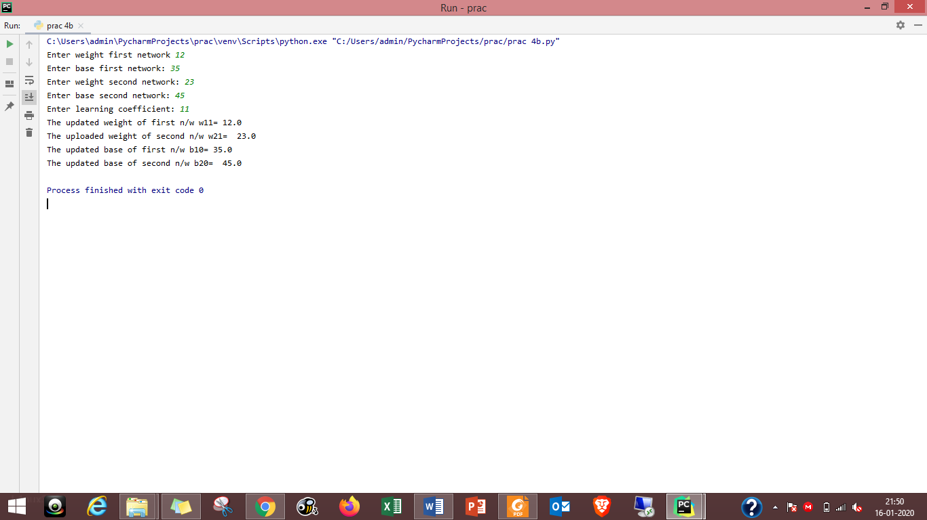

PRACTICAL NO: 05 (A)
Title: Write a program for Hopfield Network.
Source Code:
#include "hop.h"
neuron::neuron(int *j)
{
inti;
for(i=0;i<4;i++)
{
weightv[i]= *(j+i);
}
}
int neuron::act(int m, int *x)
{
inti;
int a=0;
for(i=0;i<m;i++)
{
a += x[i]*weightv[i];
}
return a;
}
int network::threshld(int k)
{
if(k>=0)
return (1);
else
return (0);
}
network::network(int a[4],int b[4],int c[4],int d[4])
{
nrn[0] = neuron(a) ;
nrn[1] = neuron(b) ;
nrn[2] = neuron(c) ;
nrn[3] = neuron(d) ;
}
void network::activation(int *patrn)
{
int i,j;
for(i=0;i<4;i++)
{
for(j=0;j<4;j++)
{
cout<<"\n nrn["<<i<<"].weightv["<<j<<"] is "
<<nrn[i].weightv[j];
}
nrn[i].activation = nrn[i].act(4,patrn);
cout<<"\nactivation is "<<nrn[i].activation;
output[i]=threshld(nrn[i].activation);
cout<<"\noutput value is "<<output[i]<<"\n";
}
}
void main ()
{
int patrn1[]= {1,0,1,0},i;
int wt1[]= {0,-3,3,-3};
int wt2[]= {-3,0,-3,3};
int wt3[]= {3,-3,0,-3};
int wt4[]= {-3,3,-3,0};
cout<<"\nTHIS PROGRAM IS FOR A HOPFIELD NETWORK WITH A SINGLE LAYER OF";
cout<<"\n4 FULLY INTERCONNECTED NEURONS. THE NETWORK SHOULD RECALLTHE";
cout<<"\nPATTERNS 1010 AND 0101 CORRECTLY.\n";
//create the network by calling its constructor.
// the constructor calls neuron constructor as many times as thenumber of
// neurons in the network.
network h1(wt1,wt2,wt3,wt4);
//present a pattern to the network and get the activations of theneurons
h1.activation(patrn1);
//check if the pattern given is correctly recalled and give message
for(i=0;i<4;i++)
{
if (h1.output[i] == patrn1[i])
cout<<"\n pattern= "<<patrn1[i]<<
" output = "<<h1.output[i]<<" component matches";
else
cout<<"\n pattern= "<<patrn1[i]<<
" output = "<<h1.output[i]<<
" discrepancy occurred";
}
cout<<"\n\n";
int patrn2[]= {0,1,0,1};
h1.activation(patrn2);
for(i=0;i<4;i++)
{
if (h1.output[i] == patrn2[i])
cout<<"\n pattern= "<<patrn2[i]<<
" output = "<<h1.output[i]<<" component matches";
else
cout<<"\n pattern= "<<patrn2[i]<<
" output = "<<h1.output[i]<<
" discrepancy occurred";
}
}
======== End code of main program=============
//Hop.h
//Single layer Hopfield Network with 4 neurons
#include <stdio.h>
#include <iostream.h>
#include <math.h>
class neuron
{
protected:
int activation;
friend class network;
public:
int weightv[4];
neuron() {};
neuron(int *j) ;
int act(int, int*);
};
class network
{
public:
neuron nrn[4];
int output[4];
int threshld(int) ;
void activation(int j[4]);
network(int*,int*,int*,int*);
};
PRACTICAL NO: 05 (B)
Title: Write a program for Radial Basis function
Source Code:
from scipy import *
from scipy.linalg import norm, pinv
from matplotlib import pyplot as plt
class RBF:
def __init__(self, indim, numCenters, outdim):
self.indim =indim
self.outdim =outdim
self.numCenters =numCenters
self.centers =[random.uniform(-1, 1, indim) for i in range(numCenters)]
self.beta =8
self.W =random.random((self.numCenters, self.outdim))
def _basisfunc(self, c, d):
assert len(d) ==self.indim
return exp(-self.beta *norm(c-d)**2)
def _calcAct(self, X):
# calculate activations of RBFs
G =zeros((X.shape[0], self.numCenters), float)
for ci, c in enumerate(self.centers):
for xi, x in enumerate(X):
G[xi,ci] =self._basisfunc(c, x)
return G
def train(self, X, Y):
""" X: matrix of dimensions n x indim
y: column vector of dimension n x 1 """
# choose random center vectors from training set
rnd_idx =random.permutation(X.shape[0])[:self.numCenters]
self.centers =[X[i,:] for i in rnd_idx]
print("center", self.centers)
# calculate activations of RBFs
G =self._calcAct(X)
print (G)
# calculate output weights (pseudoinverse)
self.W =dot(pinv(G), Y)
def test(self, X):
""" X: matrix of dimensions n x indim """
G =self._calcAct(X)
Y =dot(G, self.W)
return Y
if __name__ =='__main__':
# ----- 1D Example ------------------------------------------------
n =100
x =mgrid[-1:1:complex(0,n)].reshape(n, 1)
# set y and add random noise
y =sin(3*(x+0.5)**3-1)
# y += random.normal(0, 0.1, y.shape)
# rbf regression
rbf = RBF(1, 10, 1)
rbf.train(x, y)
z = rbf.test(x)
# plot original data
plt.figure(figsize=(12, 8))
plt.plot(x, y, 'k-')
# plot learned model
plt.plot(x, z, 'r-', linewidth=2)
# plot rbfs
plt.plot(rbf.centers, zeros(rbf.numCenters), 'gs')
for c in rbf.centers:
# RF prediction lines
cx = arange(c - 0.7, c + 0.7, 0.01)
cy = [rbf._basisfunc(array([cx_]), array([c])) for cx_ in cx]
plt.plot(cx, cy, '-', color='gray', linewidth=0.2)
plt.xlim(-1.2, 1.2)
plt.show()

Output:
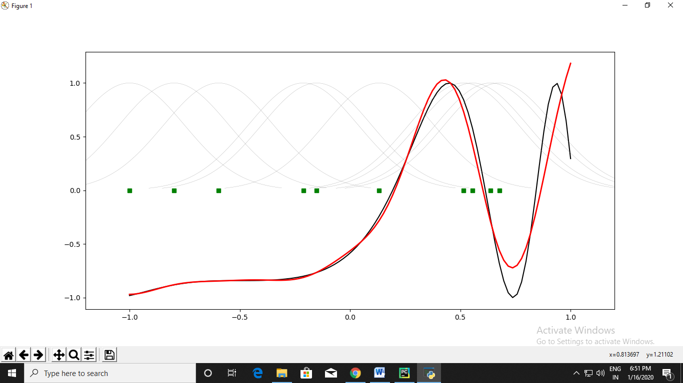

PRACTICAL NO: 06 (A)
Title: Write a program for Kohonen Self-Organizing map
Source Code:
from mvpa2.suite import *
colors = np.array(
[[0., 0., 0.],
[0., 0., 1.],
[0., 0., 0.5],
[0.125, 0.529, 1.0],
[0.33, 0.4, 0.67],
[0.6, 0.5, 1.0],
[0., 1., 0.],
[1., 0., 0.],
[0., 1., 1.],
[1., 0., 1.],
[1., 1., 0.],
[1., 1., 1.],
[.33, .33, .33],
[.5, .5, .5],
[.66, .66, .66]])
# store the names of the colors for visualization later on
color_names = \
['black', 'blue', 'darkblue', 'skyblue',
'greyblue', 'lilac', 'green', 'red',
'cyan', 'violet', 'yellow', 'white',
'darkgrey', 'mediumgrey', 'lightgrey']
som = SimpleSOMMapper((20, 30), 400, learning_rate=0.05)
som.train(colors)
pl.imshow(som.K, origin='lower')
mapped = som(colors)
pl.title('Color SOM')
# SOM's kshape is (rows x columns), while matplotlib wants (X x Y)
for i, m in enumerate(mapped):
pl.text(m[1], m[0], color_names[i], ha='center', va='center',
bbox=dict(facecolor='white', alpha=0.5, lw=0))
Output:
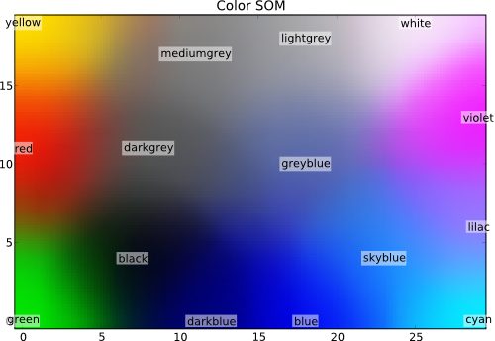
PRACTICAL NO: 06 (B)
Title: Write a program for Adaptive Resonance Theory
Source Code:
from __future__ import division
import numpy as np
from neupy.utils import format_data
from neupy.core.properties import (ProperFractionProperty,
IntProperty)
from neupy.algorithms.base import BaseNetwork
__all__ = ('ART1',)
class ART1(BaseNetwork):
"""
Adaptive Resonance Theory (ART1) Network for binary
data clustering.
Notes
-----
- Weights are not random, so the result will be
always reproduceble.
Parameters
----------
rho : float
Control reset action in training process. Value must be
between ``0`` and ``1``, defaults to ``0.5``.
n_clusters : int
Number of clusters, defaults to ``2``. Min value is also ``2``.
{BaseNetwork.Parameters}
Methods
-------
train(X)
ART trains until all clusters are found.
predict(X)
Each prediction trains a new network. It's an alias to
the ``train`` method.
{BaseSkeleton.fit}
Examples
--------
>>> import numpy as np
>>> from neupy import algorithms
>>>
>>> data = np.array([
... [0, 1, 0],
... [1, 0, 0],
... [1, 1, 0],
... ])
>>>>
>>> artnet = algorithms.ART1(
... step=2,
... rho=0.7,
... n_clusters=2,
... verbose=False
... )
>>> artnet.predict(data)
array([ 0., 1., 1.])
"""
rho = ProperFractionProperty(default=0.5)
n_clusters = IntProperty(default=2, minval=2)
def train(self, X):
X = format_data(X)
if X.ndim != 2:
raise ValueError("Input value must be 2 dimensional, got "
"{}".format(X.ndim))
n_samples, n_features = X.shape
n_clusters = self.n_clusters
step = self.step
rho = self.rho
if np.any((X != 0) & (X != 1)):
raise ValueError("ART1 Network works only with binary matrices")
if not hasattr(self, 'weight_21'):
self.weight_21 = np.ones((n_features, n_clusters))
if not hasattr(self, 'weight_12'):
scaler = step / (step + n_clusters - 1)
self.weight_12 = scaler * self.weight_21.T
weight_21 = self.weight_21
weight_12 = self.weight_12
if n_features != weight_21.shape[0]:
raise ValueError("Input data has invalid number of features. "
"Got {} instead of {}"
"".format(n_features, weight_21.shape[0]))
classes = np.zeros(n_samples)
# Train network
for i, p in enumerate(X):
disabled_neurons = []
reseted_values = []
reset = True
while reset:
output1 = p
input2 = np.dot(weight_12, output1.T)
output2 = np.zeros(input2.size)
input2[disabled_neurons] = -np.inf
winner_index = input2.argmax()
output2[winner_index] = 1
expectation = np.dot(weight_21, output2)
output1 = np.logical_and(p, expectation).astype(int)
reset_value = np.dot(output1.T, output1) / np.dot(p.T, p)
reset = reset_value < rho
if reset:
disabled_neurons.append(winner_index)
reseted_values.append((reset_value, winner_index))
if len(disabled_neurons) >= n_clusters:
# Got this case only if we test all possible clusters
reset = False
winner_index = None
if not reset:
if winner_index is not None:
weight_12[winner_index, :] = (step * output1) / (
step + np.dot(output1.T, output1) - 1
)
weight_21[:, winner_index] = output1
else:
# Get result with the best `rho`
winner_index = max(reseted_values)[1]
classes[i] = winner_index
return classes
def predict(self, X):
return self.train(X)

PRACTICAL NO: 06 (C)
Title: Implementation of cross validation with suitable example
Source Code in R:
# tidyverse for easy data manipulation and visualization
# caret for easily computing cross-validation methods

library(tidyverse)
library(caret)
# Load the data
data("swiss")
# Inspect the data
sample_n(swiss, 3)
set.seed(123)
training.samples <- swiss$Fertility %>%
createDataPartition(p = 0.8, list = FALSE)
train.data <- swiss[training.samples, ]
test.data <- swiss[-training.samples, ]
# Build the model
model <- lm(Fertility ~., data = train.data)
predictions <- model %>% predict(test.data)
data.frame( R2 = R2(predictions, test.data$Fertility),
RMSE = RMSE(predictions, test.data$Fertility),
MAE = MAE(predictions, test.data$Fertility))

Leave one out cross validation – LOOCV
# Define training control
train.control <- trainControl(method = "LOOCV")
# Train the model
model <- train(Fertility ~., data = swiss, method = "lm",
trControl = train.control)
# Summarize the results
print(model)
K-fold cross-validation
# Define training control
set.seed(123)
train.control <- trainControl(method = "cv", number = 10)
# Train the model
model <- train(Fertility ~., data = swiss, method = "lm",
trControl = train.control)
# Summarize the results
print(model)
Repeated K-fold cross-validation
# Define training control
set.seed(123)
train.control <- trainControl(method = "repeatedcv",
number = 10, repeats = 3)
# Train the model
model <- train(Fertility ~., data = swiss, method = "lm",
trControl = train.control)
# Summarize the results
print(model)
PRACTICAL NO: 07 (A)
Title: Write a program for line separation
Source Code:
import numpy as np
import matplotlib.pyplot as plt
def create_distance_function(a, b, c):
""" 0 = ax + by + c """
def distance(x, y):
""" returns tuple (d, pos)
d is the distance
If pos == -1 point is below the line,
0 on the line and +1 if above the line
"""
nom = a * x + b * y + c
if nom == 0:
pos = 0
elif (nom < 0 and b < 0) or (nom > 0 and b > 0):
pos = -1
else:
pos = 1
return (np.absolute(nom) / np.sqrt(a ** 2 + b ** 2), pos)
return distance
points = [(3.5, 1.8), (1.1, 3.9)]
fig, ax = plt.subplots()
ax.set_xlabel("sweetness")
ax.set_ylabel("sourness")
ax.set_xlim([-1, 6])
ax.set_ylim([-1, 8])
X = np.arange(-0.5, 5, 0.1)
colors = ["r", ""] # for the samples
size = 10
for (index, (x, y)) in enumerate(points):
if index == 0:
ax.plot(x, y, "o",
color="darkorange",
markersize=size)
else:
ax.plot(x, y, "oy",
markersize=size)
step = 0.05
for x in np.arange(0, 1 + step, step):
slope = np.tan(np.arccos(x))
dist4line1 = create_distance_function(slope, -1, 0)
# print("x: ", x, "slope: ", slope)
Y = slope * X
results = []
for point in points:
results.append(dist4line1(*point))
# print(slope, results)
if (results[0][1] != results[1][1]):
ax.plot(X, Y, "g-")
else:
ax.plot(X, Y, "r-")
plt.show()

Output:
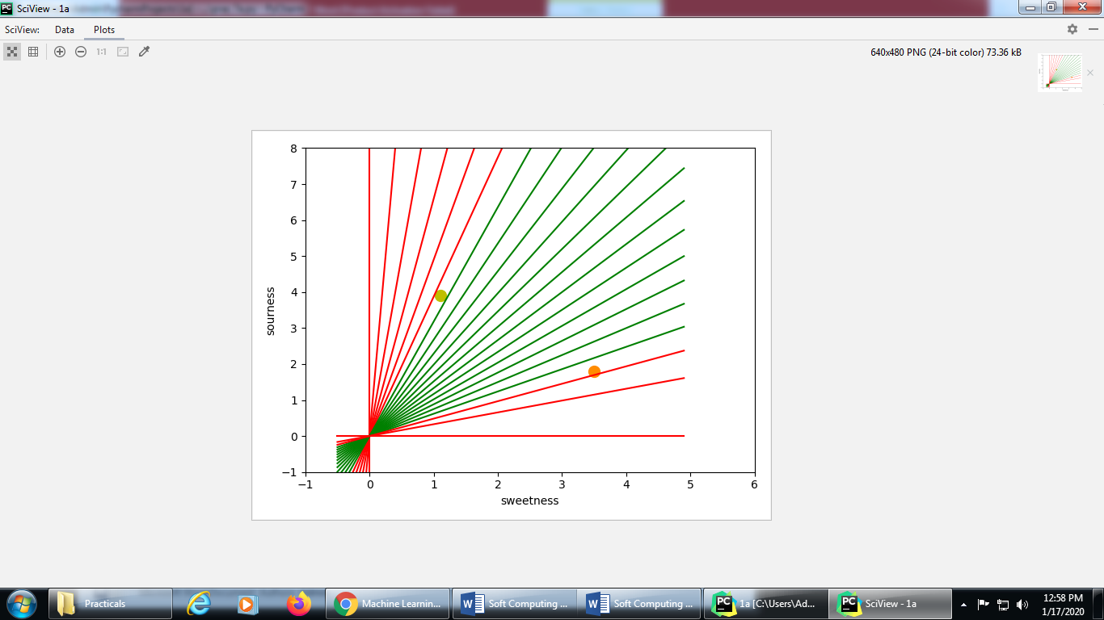
PRACTICAL NO: 07(B)
Title: Write a program for Hopfield network model of associative memory
Source Code:
import matplotlib
from neurodynex.hopfield_network import network, pattern_tools, plot_tools
pattern_size = 5
# create an instance of the class HopfieldNetwork
hopfield_net = network.HopfieldNetwork(nr_neurons= pattern_size**2)
# instantiate a pattern factory
factory = pattern_tools.PatternFactory(pattern_size, pattern_size)
# create a checkerboard pattern and add it to the pattern list
checkerboard = factory.create_checkerboard()
pattern_list = [checkerboard]
# add random patterns to the list
pattern_list.extend(factory.create_random_pattern_list(nr_patterns=3, on_probability=0.5))
plot_tools.plot_pattern_list(pattern_list)
# how similar are the random patterns and the checkerboard? Check the overlaps
overlap_matrix = pattern_tools.compute_overlap_matrix(pattern_list)
plot_tools.plot_overlap_matrix(overlap_matrix)
# let the hopfield network "learn" the patterns. Note: they are not stored
# explicitly but only network weights are updated !
hopfield_net.store_patterns(pattern_list)
# create a noisy version of a pattern and use that to initialize the network
noisy_init_state = pattern_tools.flip_n(checkerboard, nr_of_flips=4)
hopfield_net.set_state_from_pattern(noisy_init_state)
# from this initial state, let the network dynamics evolve.
states = hopfield_net.run_with_monitoring(nr_steps=4)
# each network state is a vector. reshape it to the same shape used to create the patterns.
states_as_patterns = factory.reshape_patterns(states)
# plot the states of the network
plot_tools.plot_state_sequence_and_overlap(states_as_patterns, pattern_list, reference_idx=0, suptitle="Network dynamics")

Output:
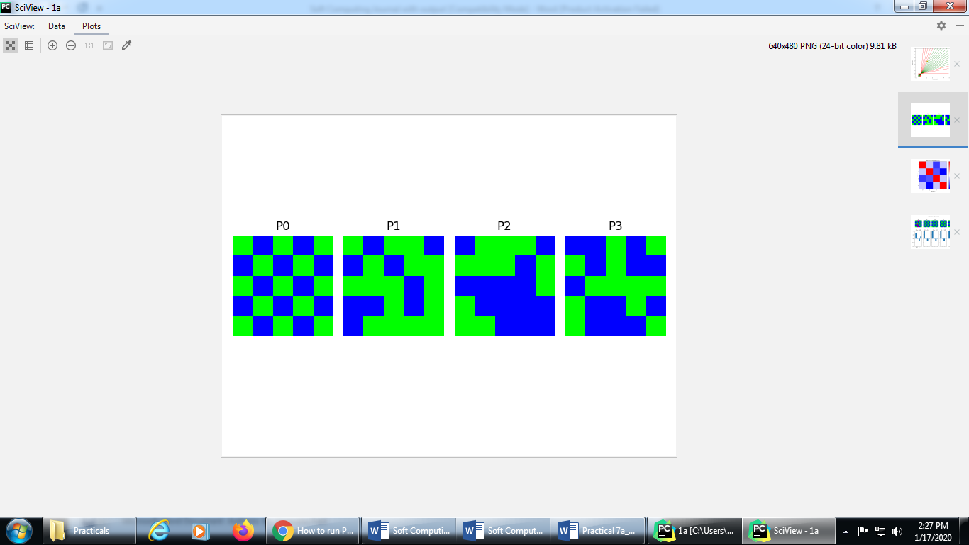

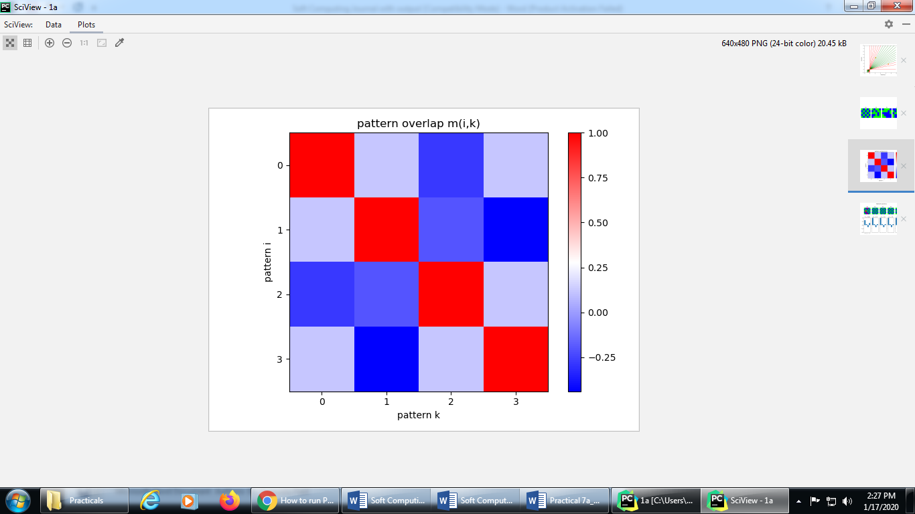
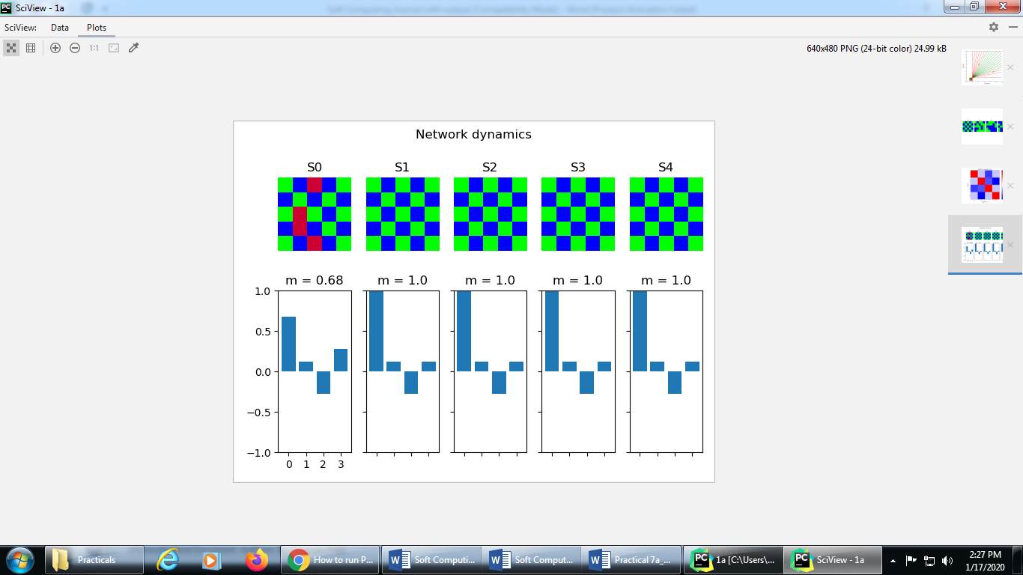

PRACTICAL NO: 08 (A)
Title: Implement the membership operator: in, not in
Source Code:
# Aim: write a program to find the whether there is common member in two list
# Define a function() that takes two lists
def overlapping(list1,list2):
c = len( list1 )
d = len( list2 )
print( "List 1: ", list1 )
print( "The length of List 1: ", c )
print( "List 2: ", list2 )
print( "The length of List 2: ", d )
for i in range(0,c):
for j in range(0,d):
if(list1[i]==list2[j]):
return 1
return 0
#end of the function

list1=[]
list2=[]
c=int(input("Enter the number of elements that you want to insert in List 1:"))
for i in range(0,c):
ele = int(input("Enter the element "))
list1.append(ele)
d=int(input("Enter the number of elements that you want to insert in List 2:"))
for i in range(0,d):
ele = int(input("Enter the element "))
list2.append(ele)
if(overlapping(list1,list2)):
print("The lists are overlapping")
else:
print("The lists are not overlapping")

Output
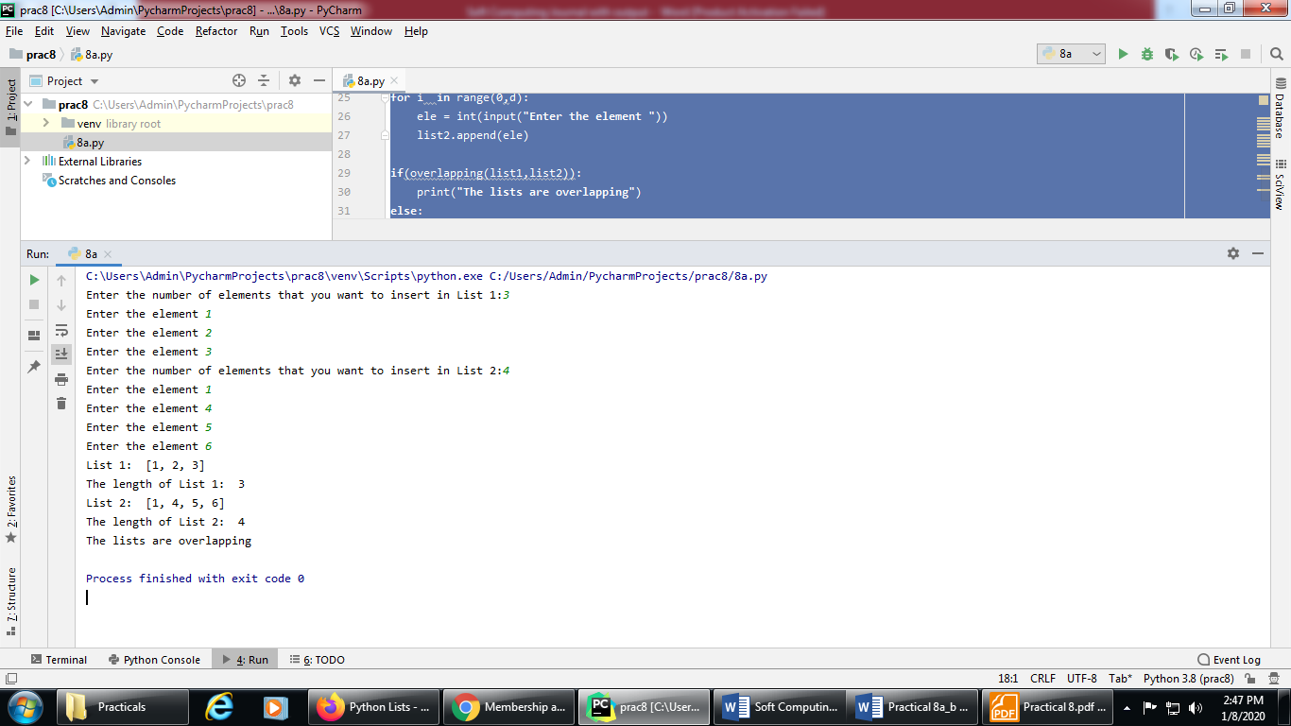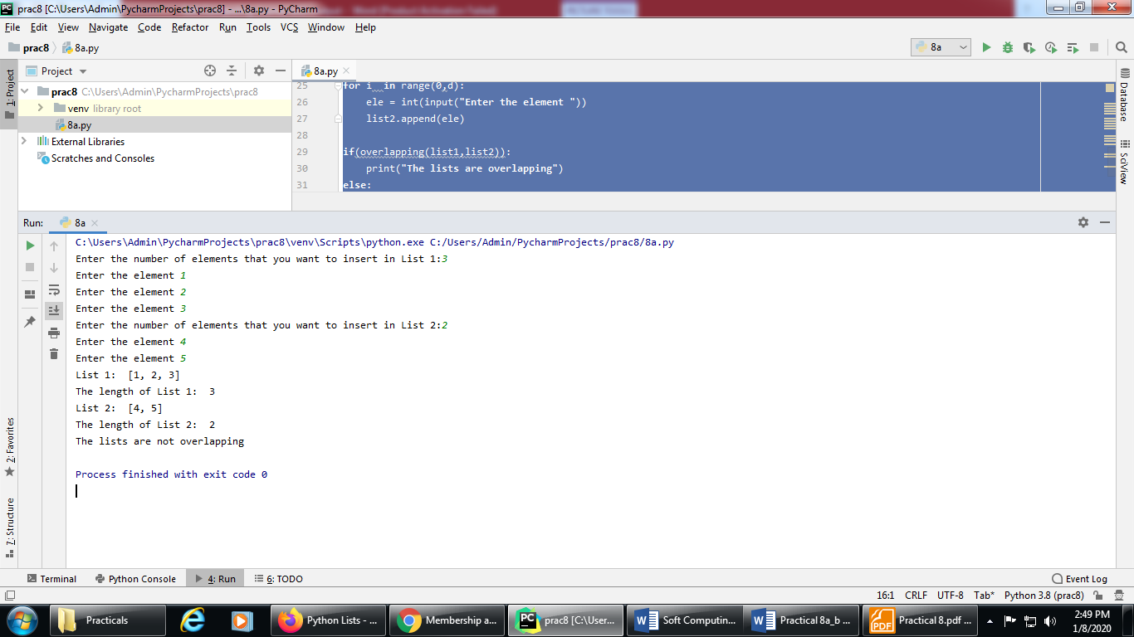

Source code:
# Aim: Not in operator in python
list1=[]
c=int(input("Enter the number of elements that you want to insert in List 1:"))
for i in range(0,c):
ele = int(input("Enter the element :"))
list1.append(ele)
a = int(input("enter the number that you want to find in List 1:"))
if a not in list1:
print( "The list does not contain ", a )
else:
print( "The list contains", a )

Output:
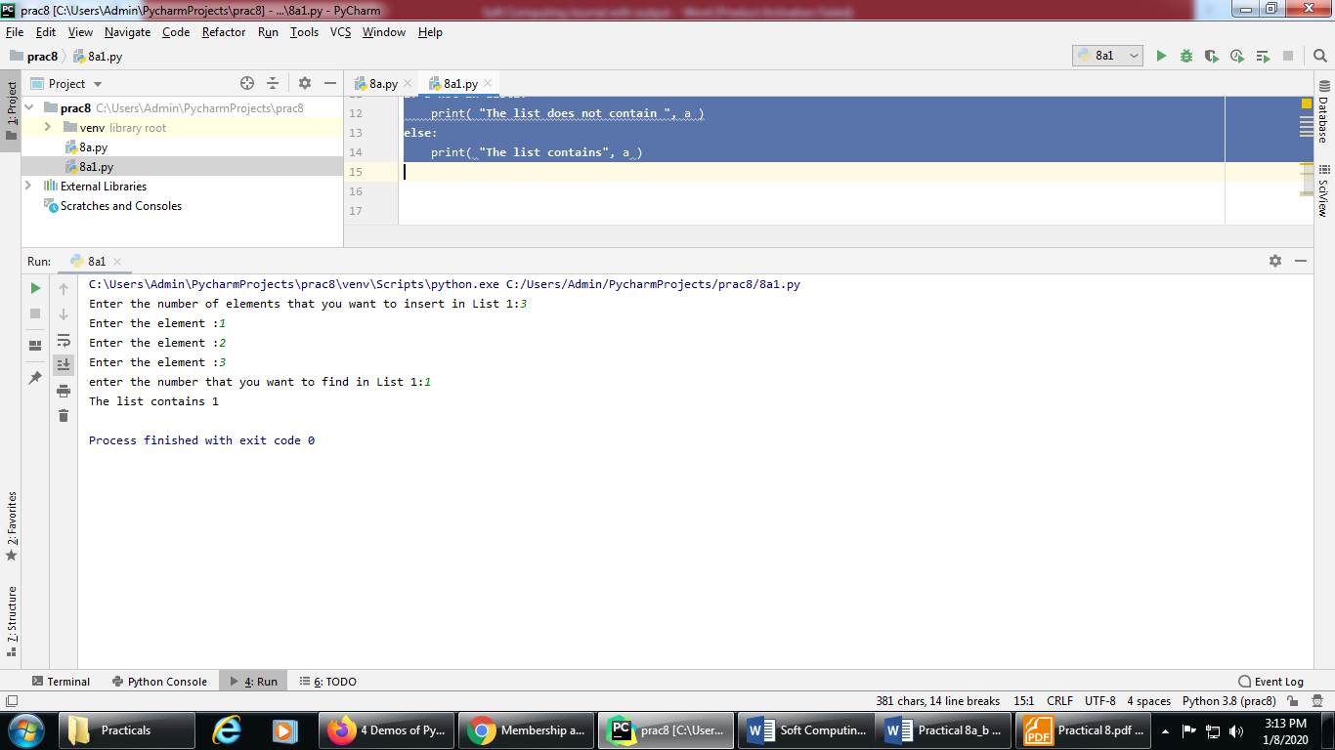
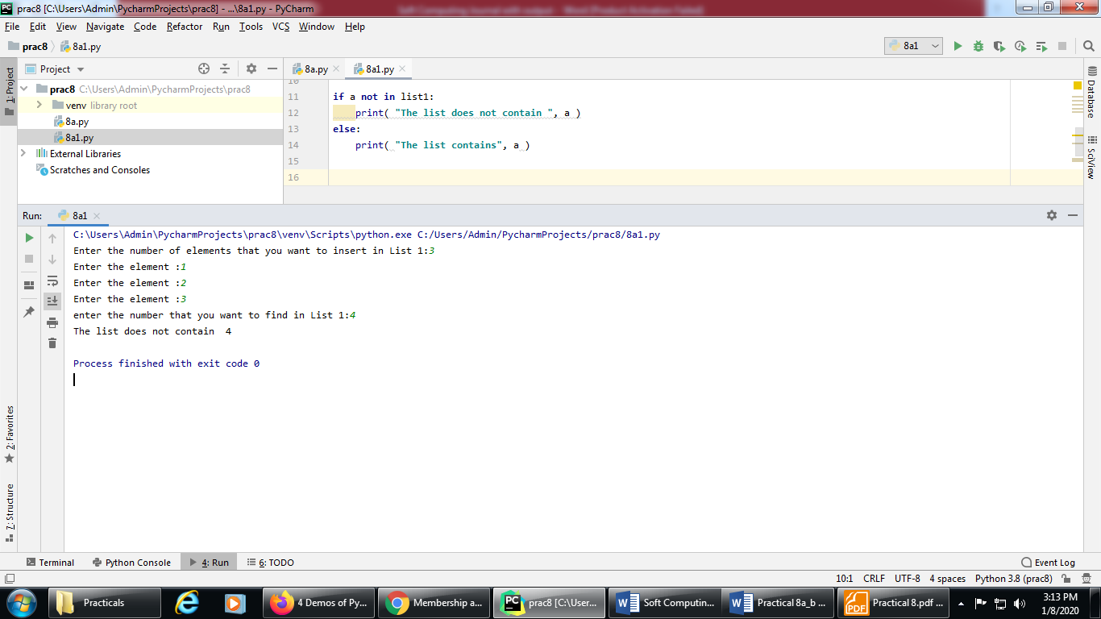
PRACTICAL NO: 08 (B)
Title: Implement the identity operator: is, is not
Source Code:
my_new_list1 = [1, 2, 3, 'a']
my_new_list2 = my_new_list1
my_new_tuple1 = (1, 2, 3, 'a')
my_new_tuple2 = (4, 5, 'b', 'a')
print("my_new_list1", my_new_list1)
print("type of my_new_list1",type(my_new_list1))
print("my_new_list2", my_new_list2)
print("type of my_new_list2",type(my_new_list2))
print("my_new_tuple1", my_new_tuple1)
print("type of my_new_tuple1", type(my_new_tuple1))
print("my_new_tuple2", my_new_tuple2)
print("type of my_new_tuple2", type(my_new_tuple2))
if type(my_new_list1) is type(my_new_tuple1):
print('my_new_list1 & my_new_tuple1 belong to same type')
else:
print("my_new_list1 & my_new_tuple1 does not belong to same type")
if type(my_new_tuple1) is type(my_new_tuple2):
print('my_new_tuple1 & my_new_tuple2 belong to same type')
else:
print("my_new_tuple1 & my_new_tuple2 does not belong to same type")
if (my_new_list1) is (my_new_list2):
print("my_new_list1 & my_new_list2 are same")
else:
print("my_new_list1 & my_new_list2 are not same")
Output:
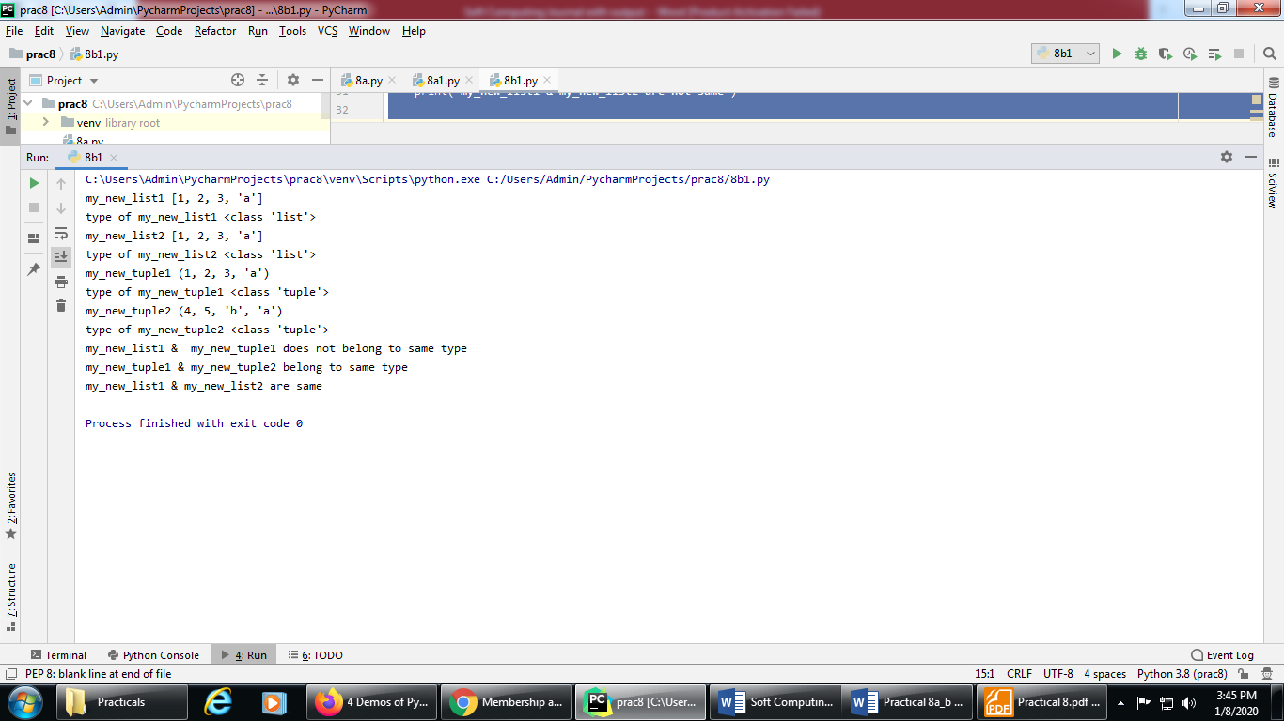

Source Code:
my_new_list1 = [1, 2, 3, 'a']
my_new_list2 = my_new_list1
my_new_tuple1 = (1, 2, 3, 'a')
my_new_tuple2 = (4, 5, 'b', 'a')
print("my_new_list1", my_new_list1)
print("type of my_new_list1",type(my_new_list1))
print("my_new_list2", my_new_list2)
print("type of my_new_list2",type(my_new_list2))
print("my_new_tuple1", my_new_tuple1)
print("type of my_new_tuple1", type(my_new_tuple1))
print("my_new_tuple2", my_new_tuple2)
print("type of my_new_tuple2", type(my_new_tuple2))
if type(my_new_list1) is not type(my_new_tuple1):
print('true!!! ,my_new_list1 & my_new_tuple1 does not belong to same type')
else:
print("my_new_list1 & my_new_tuple1 belong to same type")
if type(my_new_tuple1) is not type(my_new_tuple2):
print('true!!!, my_new_tuple1 & my_new_tuple2 does not belong to same type')
else:
print("my_new_tuple1 & my_new_tuple2 belong to same type")
if (my_new_list1) is not (my_new_list2):
print("true!!!, my_new_list1 & my_new_list2 are not same")
else:
print("my_new_list1 & my_new_list2 are same")

Output:
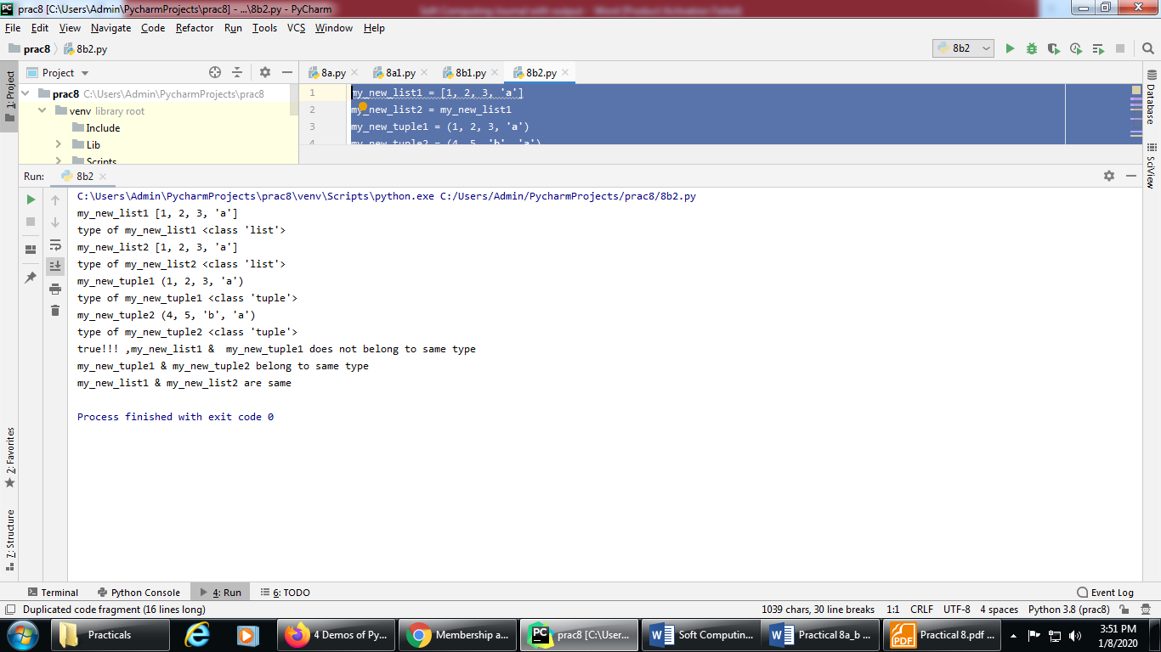
PRACTICAL NO: 09 (A)
Title: Find the ratios using fuzzy logic
Source Code:
pip install fuzzywuzzy
pip install python-Levenshtein

# Python code showing all the ratios together,
# make sure you have installed fuzzywuzzy module
from fuzzywuzzy import fuzz
from fuzzywuzzy import process
s1 = "I love GeeksforGeeks"
s2 = "I am loving GeeksforGeeks"
print("FuzzyWuzzy Ratio: ", fuzz.ratio( s1, s2 ))
print("FuzzyWuzzy PartialRatio: ", fuzz.partial_ratio( s1, s2 ))
print("FuzzyWuzzy TokenSortRatio: ", fuzz.token_sort_ratio( s1, s2 ))
print("FuzzyWuzzy TokenSetRatio: ", fuzz.token_set_ratio( s1, s2 ))
print("FuzzyWuzzy WRatio: ", fuzz.WRatio( s1, s2 ), '\n\n')
# for process library,
query = 'geeks for geeks'
choices = ['geek for geek', 'geek geek', 'g. for geeks']
print("List of ratios: ")
print(process.extract( query, choices ), '\n')
print("Best among the above list: ", process.extractOne( query, choices ))

Output:
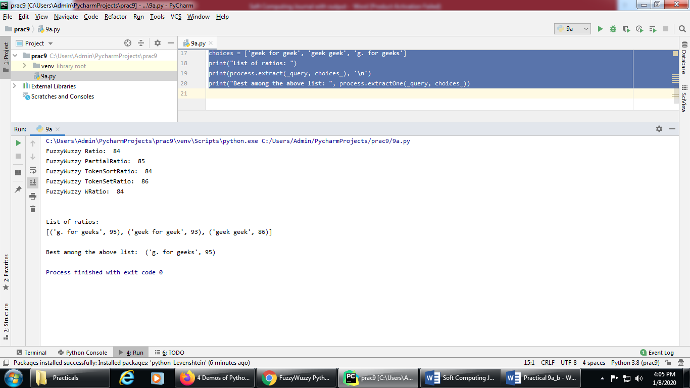

PRACTICAL NO: 09 (B)
Title: Solve Tipping Problem using fuzzy logic
Source Code:
import numpy as np
import skfuzzy as fuzz
from skfuzzy import control as ctrl
# New Antecedent/Consequent objects hold universe variables and membership
# functions
#np.arange will give a array starting from zero to 11, with increment of 1
quality = ctrl.Antecedent(np.arange(0, 11, 1), 'quality')
service = ctrl.Antecedent(np.arange(0, 11, 1), 'service')
tip = ctrl.Consequent(np.arange(0, 26, 1), 'tip')
# Auto-membership function population is possible with .automf(3, 5, or 7)
quality.automf(3)
service.automf(3)
# Custom membership functions can be built interactively with a familiar,
# Pythonic API
#trimf() is triangular membership generator
tip['low'] = fuzz.trimf(tip.universe, [0, 0, 13])
tip['medium'] = fuzz.trimf(tip.universe, [0, 13, 25])
tip['high'] = fuzz.trimf(tip.universe, [13, 25, 25])
# You can see how these look with .view()
#quality['average'].view()
#service['poor'].view()
#tip['high'].view()
#rule to implemented
rule1 = ctrl.Rule(quality['poor'] | service['poor'], tip['low'])
rule2 = ctrl.Rule(service['average'], tip['medium'])
rule3 = ctrl.Rule(service['good'] | quality['good'], tip['high'])
rule1.view()
# rule2.view()
# rule3.view()
tipping_ctrl = ctrl.ControlSystem([rule1, rule2, rule3])
tipping = ctrl.ControlSystemSimulation(tipping_ctrl)
# Pass inputs to the ControlSystem using Antecedent labels with Pythonic API
# Note: if you like passing many inputs all at once, use .inputs(dict_of_data)
tipping.input['quality'] = 6.5
tipping.input['service'] = 9.8
# Crunch the numbers
tipping.compute()
print (tipping.output['tip'])
tip.view(sim=tipping)

Output:
quality['average'].view()
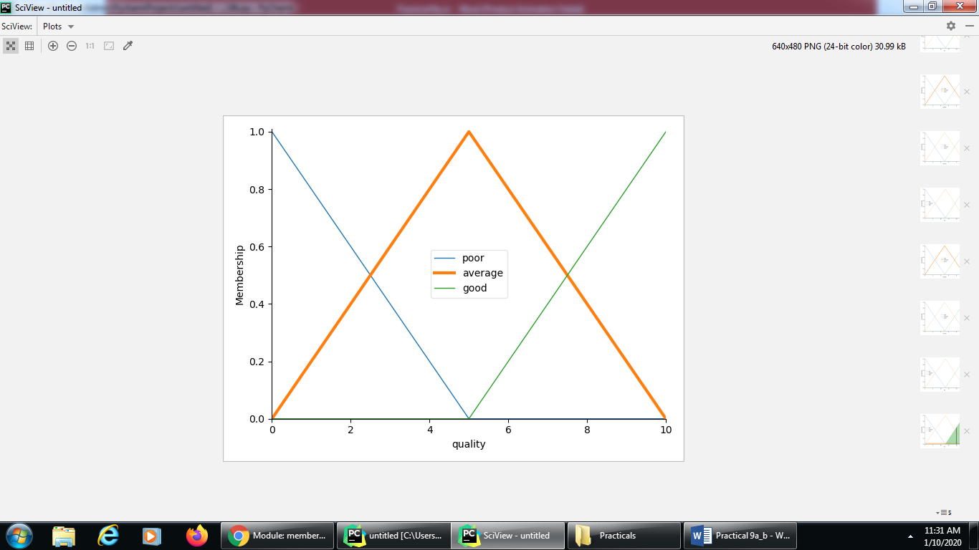
service['poor'].view()
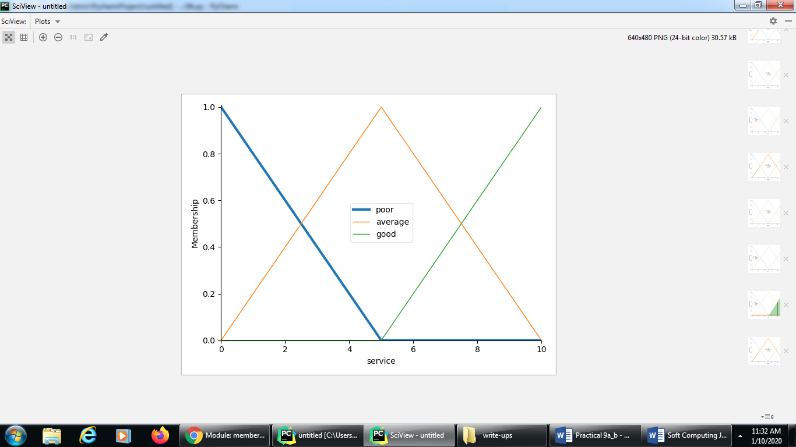

tip['high'].view()
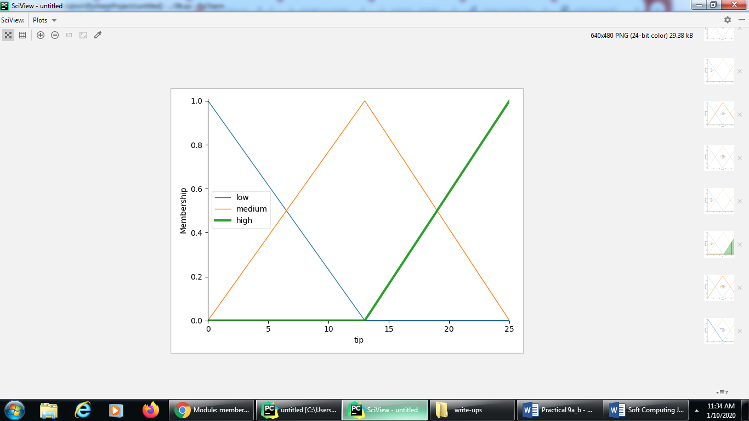
rule1.view()
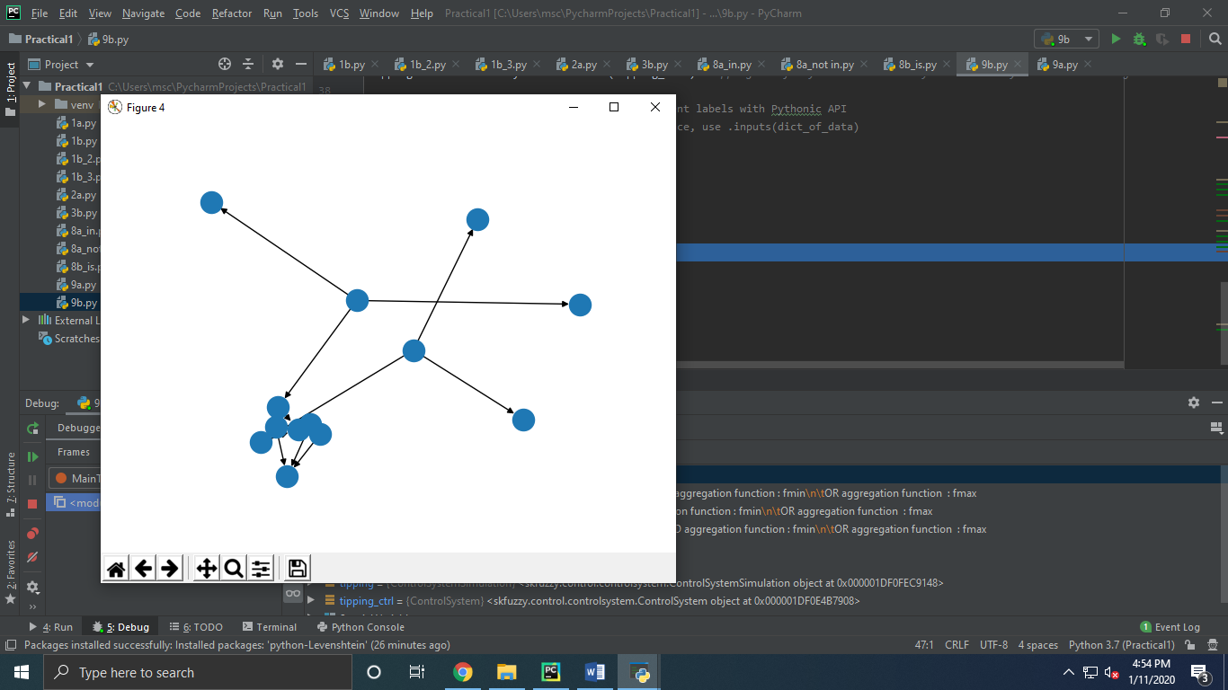

print (tipping.output['tip'])
tip.view(sim=tipping)
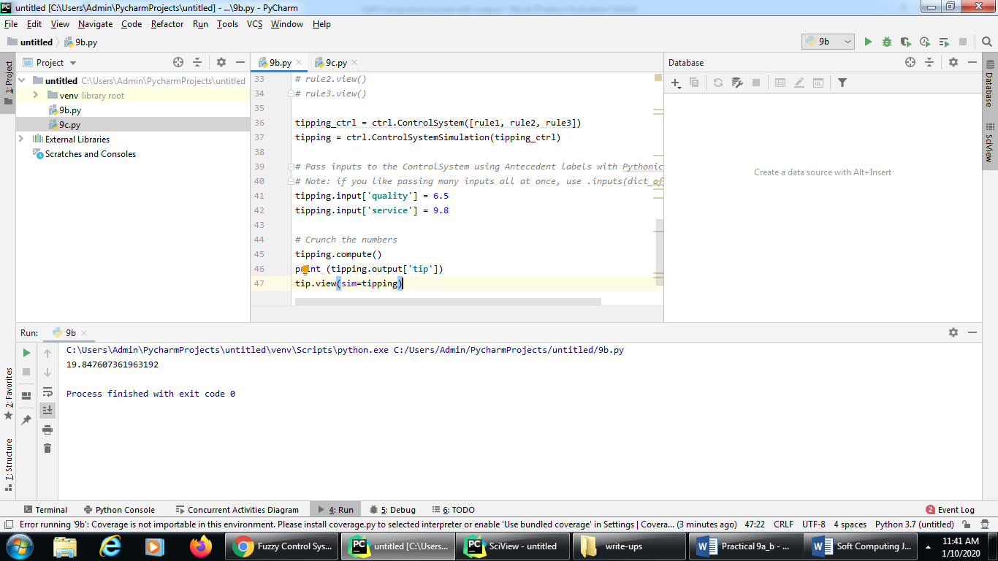

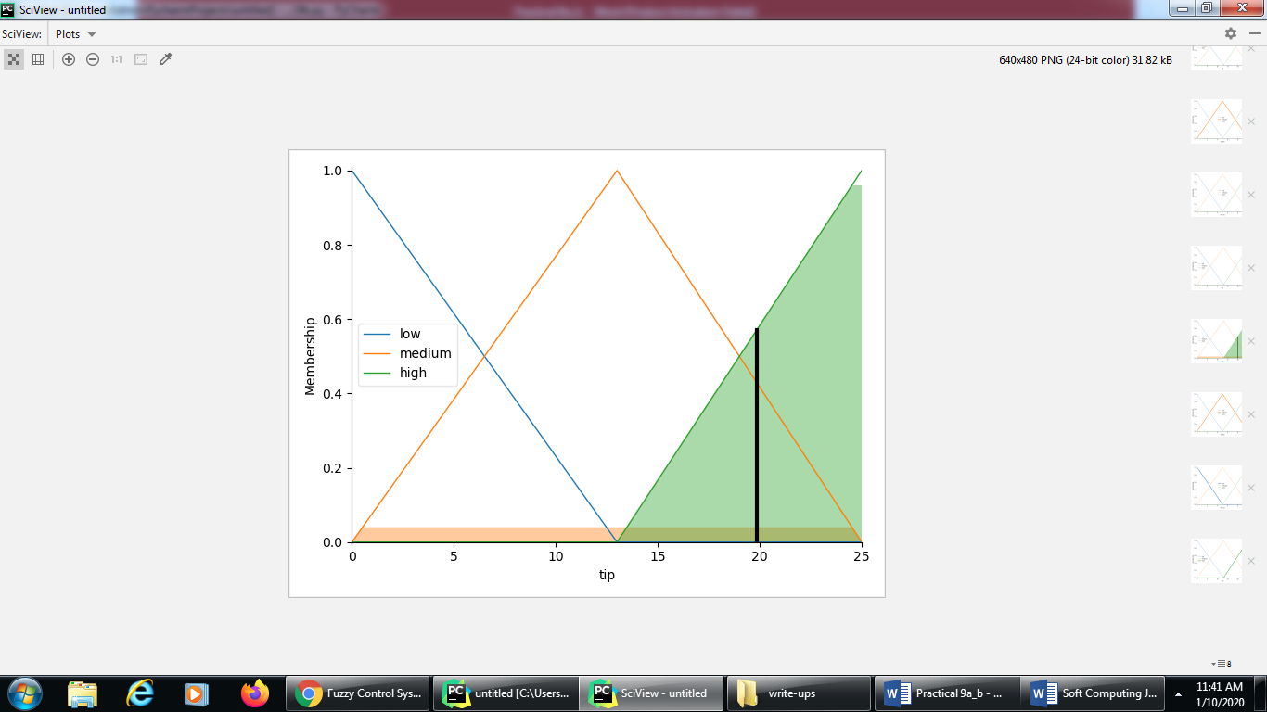

PRACTICAL NO: 10 (A)
Title: Implementation of simple genetic algorithm
Source Code:
import random
# Number of individuals in each generation
POPULATION_SIZE = 100
# Valid genes
GENES = '''abcdefghijklmnopqrstuvwxyzABCDEFGHIJKLMNOP
QRSTUVWXYZ 1234567890, .-;:_!"#%&/()=?@${[]}'''
# Target string to be generated
TARGET = "I love GeeksforGeeks"
class Individual( object ):
'''
Class representing individual in population
'''
def __init__(self, chromosome):
self.chromosome = chromosome
self.fitness = self.cal_fitness()
@classmethod
def mutated_genes(self):
'''
create random genes for mutation
'''
global GENES
gene = random.choice( GENES )
return gene
@classmethod
def create_gnome(self):
'''
create chromosome or string of genes
'''
global TARGET
gnome_len = len( TARGET )
return [self.mutated_genes() for _ in range( gnome_len )]
def mate(self, par2):
'''
Perform mating and produce new offspring
'''
# chromosome for offspring
child_chromosome = []
for gp1, gp2 in zip( self.chromosome, par2.chromosome ):
# random probability
prob = random.random()
# if prob is less than 0.45, insert gene
# from parent 1
if prob < 0.45:
child_chromosome.append( gp1 )
# if prob is between 0.45 and 0.90, insert
# gene from parent 2
elif prob < 0.90:
child_chromosome.append( gp2 )
# otherwise insert random gene(mutate),
# for maintaining diversity
else:
child_chromosome.append( self.mutated_genes() )
# create new Individual(offspring) using
# generated chromosome for offspring
return Individual( child_chromosome )
def cal_fitness(self):
'''
Calculate fittness score, it is the number of
characters in string which differ from target
string.
'''
global TARGET
fitness = 0
for gs, gt in zip( self.chromosome, TARGET ):
if gs != gt: fitness += 1
return fitness
# Driver code
def main():
global POPULATION_SIZE
# current generation
generation = 1
found = False
population = []
# create initial population
for _ in range( POPULATION_SIZE ):
gnome = Individual.create_gnome()
population.append( Individual( gnome ) )
while not found:
# sort the population in increasing order of fitness score
population = sorted( population, key=lambda x: x.fitness )
# if the individual having lowest fitness score ie.
# 0 then we know that we have reached to the target
# and break the loop
if population[0].fitness <= 0:
found = True
break
# Otherwise generate new offsprings for new generation
new_generation = []
# Perform Elitism, that mean 10% of fittest population
# goes to the next generation
s = int( (10 * POPULATION_SIZE) / 100 )
new_generation.extend( population[:s] )
# From 50% of fittest population, Individuals
# will mate to produce offspring
s = int( (90 * POPULATION_SIZE) / 100 )
for _ in range( s ):
parent1 = random.choice( population[:50] )
parent2 = random.choice( population[:50] )
child = parent1.mate( parent2 )
new_generation.append( child )
population = new_generation
print( "Generation: {}\tString: {}\tFitness: {}". \
format( generation,
"".join( population[0].chromosome ),
population[0].fitness ) )
generation += 1
print( "Generation: {}\tString: {}\tFitness: {}". \
format( generation,
"".join( population[0].chromosome ),
population[0].fitness ) )
if __name__ == '__main__':
main()

Output:
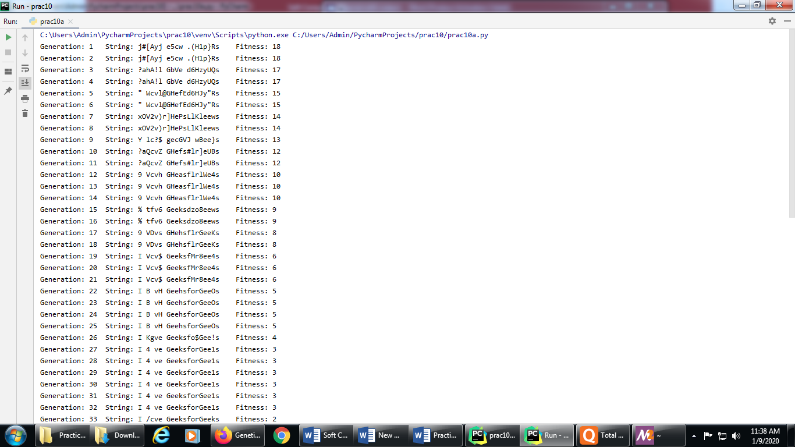

PRACTICAL NO: 10 (B)
Title: Solve Travelling salesman problem (TSP) using GA
Source Code:
#Aim: Solve Travelling salesman problem (TSP) using GA
import numpy as np, random, operator, pandas as pd, matplotlib.pyplot as plt
# We first create a City class that will allow us to create and handle our cities.
# These are simply our (x, y) coordinates. Within the City class,
# we add a distance calculation (making use of the Pythagorean theorem)
# and a cleaner way to output the cities as coordinates with __repr__.
class City:
def __init__(self, x, y):
self.x = x
self.y = y
def distance(self, city):
xDis = abs(self.x - city.x)
yDis = abs(self.y - city.y)
distance = np.sqrt((xDis ** 2) + (yDis ** 2))
return distance
def __repr__(self):
return "(" + str(self.x) + "," + str(self.y) + ")"
# We’ll also create a Fitness class. In our case, we’ll treat the fitness as the inverse of the #route distance.
# We want to minimize route distance, so a larger fitness score is better.
# Based on Rule #2, we need to start and end at the same place,
# so this extra calculation is accounted for the distance calculation.
class Fitness:
def __init__(self, route):
self.route = route
self.distance = 0
self.fitness = 0.0
def routeDistance(self):
if self.distance == 0:
pathDistance = 0
for i in range(0, len(self.route)):
fromCity = self.route[i]
toCity = None
if i + 1 < len(self.route):
toCity = self.route[i + 1]
else:
toCity = self.route[0]
pathDistance += fromCity.distance(toCity)
self.distance = pathDistance
return self.distance
def routeFitness(self):
if self.fitness == 0:
self.fitness = 1 / float(self.routeDistance())
return self.fitness
#Creating the population:
#We now can make our initial population (aka first generation).
# To do so, we need a way to create a function that produces routes that satisfy our #conditions
# To create an individual, we randomly select the order in which we visit each city:
def createRoute(cityList):
route = random.sample(cityList, len(cityList))
return route
#This produces one individual, but we want a full population, so let’s do that in our next #function.
# This is as simple as looping through the createRoute function until
# we have as many routes as we want for our population.
def initialPopulation(popSize, cityList):
population = []
for i in range(0, popSize):
population.append(createRoute(cityList))
return population
#Determine Fitness:
#To simulate our “survival of the fittest”,
# we can make use of Fitness to rank each individual in the population.
# Our output will be an ordered list with the route IDs and each associated fitness score.
def rankRoutes(population):
fitnessResults = {}
for i in range(0,len(population)):
fitnessResults[i] = Fitness(population[i]).routeFitness()
return sorted(fitnessResults.items(), key = operator.itemgetter(1), reverse = True)
#Select the mating Pool:
#For the purpose of clarity, we’ll create the mating pool in two steps.
# First, we’ll use the output from rankRoutes to determine which routes to select in our #selection function.
# We set up the roulette wheel by calculating a relative fitness weight for each individual.
# We compare a randomly drawn number to these weights to select our mating pool.
# We’ll also want to hold on to our best routes, so we introduce elitism.
# Ultimately, the selection function returns a list of route IDs,
# which we can use to create the mating pool in the matingPool function.
def selection(popRanked, eliteSize):
selectionResults = []
df = pd.DataFrame(np.array(popRanked), columns=["Index", "Fitness"])
df['cum_sum'] = df.Fitness.cumsum()
df['cum_perc'] = 100 * df.cum_sum / df.Fitness.sum()
for i in range(0, eliteSize):
selectionResults.append(popRanked[i][0])
for i in range(0, len(popRanked) - eliteSize):
pick = 100 * random.random()
for i in range(0, len(popRanked)):
if pick <= df.iat[i, 3]:
selectionResults.append(popRanked[i][0])
break
return selectionResults
#Now that we have the IDs of the routes that will make up our mating pool from the #selection function,
# we can create the mating pool. We’re simply extracting the selected individuals from our #population.
def matingPool(population, selectionResults):
matingpool = []
for i in range(0, len(selectionResults)):
index = selectionResults[i]
matingpool.append(population[index])
return matingpool
#Breed:
#With our mating pool created, we can create the next generation in a process called crossover (aka “breeding”).
#the TSP is unique in that we need to include all locations exactly one time.
# To abide by this rule, we can use a special breeding function called ordered crossover.
# In ordered crossover, we randomly select a subset of the first parent string (see line 12 in #breed function below)
# and then fill the remainder of the route with the genes from the second parent in the #order in which they appear,
# without duplicating any genes in the selected subset from the first parent
def breed(parent1, parent2):
child = []
childP1 = []
childP2 = []
geneA = int(random.random() * len(parent1))
geneB = int(random.random() * len(parent1))
startGene = min(geneA, geneB)
endGene = max(geneA, geneB)
for i in range(startGene, endGene):
childP1.append(parent1[i])
childP2 = [item for item in parent2 if item not in childP1]
child = childP1 + childP2
return child
#we’ll generalize this to create our offspring population.
# We use elitism to retain the best routes from the current population.
# Then, we use the breed function to fill out the rest of the next generation.
def breedPopulation(matingpool, eliteSize):
children = []
length = len(matingpool) - eliteSize
pool = random.sample(matingpool, len(matingpool))
for i in range(0, eliteSize):
children.append(matingpool[i])
for i in range(0, length):
child = breed(pool[i], pool[len(matingpool) - i - 1])
children.append(child)
return children
#Mutate:
#Mutation serves an important function in GA, as it helps to avoid local convergence by #introducing novel routes
# that will allow us to explore other parts of the solution space.
# Similar to crossover, the TSP has a special consideration when it comes to mutation.
#since we need to abide by our rules, we can’t drop cities. Instead, we’ll use swap mutation.
# This means that, with specified low probability, two cities will swap places in our route.
# We’ll do this for one individual in our mutate function:
def mutate(individual, mutationRate):
for swapped in range(len(individual)):
if (random.random() < mutationRate):
swapWith = int(random.random() * len(individual))
city1 = individual[swapped]
city2 = individual[swapWith]
individual[swapped] = city2
individual[swapWith] = city1
return individual
#Next, we can extend the mutate function to run through the new population.
def mutatePopulation(population, mutationRate):
mutatedPop = []
for ind in range(0, len(population)):
mutatedInd = mutate(population[ind], mutationRate)
mutatedPop.append(mutatedInd)
return mutatedPop
#We’re almost there. Let’s pull these pieces together to create a function that produces a #new generation.
# First, we rank the routes in the current generation using rankRoutes.
# We then determine our potential parents by running the selection function,
# which allows us to create the mating pool using the matingPool function.
# Finally, we then create our new generation using the breedPopulation function and
# then applying mutation using the mutatePopulation function.
def nextGeneration(currentGen, eliteSize, mutationRate):
popRanked = rankRoutes(currentGen)
selectionResults = selection(popRanked, eliteSize)
matingpool = matingPool(currentGen, selectionResults)
children = breedPopulation(matingpool, eliteSize)
nextGeneration = mutatePopulation(children, mutationRate)
return nextGeneration
#We finally have all the pieces in place to create our GA!
# All we need to do is create the initial population, and then we can loop through as many #generations as we desire.
# Of course we also want to see the best route and how much we’ve improved, so we #capture the initial distance
# the final distance and the best route
def geneticAlgorithm(population, popSize, eliteSize, mutationRate, generations):
pop = initialPopulation(popSize, population)
print("Initial distance: " + str(1 / rankRoutes(pop)[0][1]))
for i in range(0, generations):
pop = nextGeneration(pop, eliteSize, mutationRate)
print("Final distance: " + str(1 / rankRoutes(pop)[0][1]))
bestRouteIndex = rankRoutes(pop)[0][0]
bestRoute = pop[bestRouteIndex]
return bestRoute
#Running the genetic algorithm
#First, we need a list of cities to travel between. For this demonstration, we’ll create a list #of 25 random cities
cityList = []
for i in range(0,25):
cityList.append(City(x=int(random.random() * 200), y=int(random.random() * 200)))
#Then, running the genetic algorithm is one simple line of code. This is where art meets #science;
# you should see which assumptions work best for you. In this example, we have 100 #individuals in each generation,
# keep 20 elite individuals, use a 1% mutation rate for a given gene, and run through 500 generations:
geneticAlgorithm(population=cityList, popSize=100, eliteSize=20, mutationRate=0.01, generations=500)
# we can store the shortest distance from each generation in a progress list and then plot #the results.
def geneticAlgorithmPlot(population, popSize, eliteSize, mutationRate, generations):
pop = initialPopulation(popSize, population)
progress = []
progress.append(1 / rankRoutes(pop)[0][1])
for i in range(0, generations):
pop = nextGeneration(pop, eliteSize, mutationRate)
progress.append(1 / rankRoutes(pop)[0][1])
plt.plot(progress)
plt.ylabel('Distance')
plt.xlabel('Generation')
plt.show()
#Run the GA in the same way as before, but now using the newly created #geneticAlgorithmPlot function
geneticAlgorithmPlot(population=cityList, popSize=100, eliteSize=20, mutationRate=0.01, generations=500)

Output:
